Trinity Metro


2023 – 2026 Title VI Program & Report


Table of Contents
Introduction 6
About Trinity Metro 6
Trinity Metro’s Commitment to Civil Rights 6
Title VI Program Development 7
Decision Making Bodies - Representation 7
Non-Elected Committees and Councils 7
On-Demand Advisory Committee 7
Bike Share Committee 8
TRE Advisory Committee 8
Route Monitoring Committee 8
Membership of Non-Elected Committees 8
Trinity Metro System Map 9
Trinity Metro Plans & Programs 10
Public Participation Plan 10
Language Assistance 10
Title VI Program 10
Notice to the Public 10
Civil Rights 10
Procedures for Filing a Discrimination Complaint 11
Modes of Service 13
Service Standards & Policies 13
Service Change Process 14
Major Service Change Policy 15
Title VI Equity Analysis 16
Disparate Impact Policy 16
Disproportionate Burden Policy 17
Title VI Service Change Equity Analysis Methodology 17
Route Improvement Plan 19
Monitoring of Service Standards 19
Performance Report 19
Customer Comments 20
Field Checks 20
Boarding and Alighting 20
Origin-Destination Survey 20
Consideration 21
Fare Change Evaluation Process 22
Title VI Fare Change Analysis Methodology 22
Consideration 24
2023 – 2025 TITLE VI ASSESSMENT 25
Minority and Low-Income Populations 25
Minority Population Defined 25
Minority Routes Defined 26
Minority Census Tracts Map 26
Low-Income Population Defined 28
Low-income Routes Defined 28
Low-Income Census Tracts Map 28
Table: Minority and Low-Income Classification of Bus Routes 30
Assessment of Minority and Low Income Populations 30
Analysis of 2023 – 2025 Operation 32
Route Classification 32
Load Factor Service Standard 33
Load Factor Assessment 34
Vehicle Assignment Standards 35
Assignment of Fixed Route Buses 35
Assessment of Fixed Route Bus Assignment 36
Assessment of Commuter Rail Vehicle Assignment 36
Vehicle Headway Service Standards 36
Vehicle Headway Assessment 37
Average Vehicle Headway Comparison – Minority Routes 37
On-Time Performance Service Standards 39
On-Time Performance Analysis 40
Service Availability Standards 41
Service Availability Assessment 42
Key Performance Indicators (KPI) Standards 45
Key Performance Indicators (KPI) Assessment 45
Service Span Standards 46
Service Span Assessment 48
Service Standards for Amenities 50
Requests for Bus Stops and Amenities 50
Bus Stop Placement and Review Process 50
Bus Stop Spacing 50
Shelters 51
Benches 52
Amenities Distribution Assessment 56
Transit Center Distribution Assessment 65
Park & Ride Facility Standards 65
Park & Ride Facility Assessment 65
Commuter Rail Facility Standards 65
Commuter Rail Station Spacing Standards 66
Commuter Rail Facility Assessment 67
Minority and Low-Income Assessment – Additional Evaluations 68
Customer Satisfaction 68
Analysis of Public Participation 2023 – 2026 73
Public Meetings (Service Changes) 73
Open Houses 74
Title VI Program 74
Summary of Major Service Changes 75
September 17, 2023 75
September 15, 2024 75
June 8, 2025 76
January 18, 2026 76
Summary of Minor Service Changes 76
May 21, 2023 76
July 3, 2023 76
September 17, 2023 77
January 15, 2024 77
February 19, 2024 77
March 17, 2024 77
September 15, 2024 77
November 3, 2024 78
April 13, 2025 78
June 8, 2025 78
September 28, 2025 78
Summary of Fare Changes 79
Program Specific Requirements 81
Travel Patterns 81
Trip Purpose 81
Sub-recipient Compliance 87
Equity Analysis for New Facilities 87
Active Lawsuits, Complaints or Inquiries Alleging Discrimination 87
ATTACHMENT – Public Participation Plan 88
ATTACHMENT – “Notice to Beneficiaries of Protection under Title VI” 93

Introduction

About Trinity Metro
Doing business as Trinity Metro, the Fort Worth Transportation Authority (Trinity Metro) is a regional transportation authority of the State of Texas. It provides public transportation to meet the mobility needs in Tarrant County and for connections with the North Central Texas region. Trinity Metro annually provides around 8 million passenger boardings on fixed-route buses, vanpools, paratransit, mobility on demand and commuter rail. As of this writing, Trinity Metro operates 31 fixed routes, seven mobility On-Demand zones, two commuter rails (TEXRail and Trinity Railway Express, which it jointly owns and operates with Dallas Area Rapid Transit), Paratransit service, and 207 vanpools throughout the entire service area of 355 square miles. Trinity Metro is governed by an eleven-member board of directors which consists of eight Fort Worth City Council appointments and three by Tarrant County Commissioners Court.

Trinity Metro’s Service Area consists of the Full Purpose annexed areas of the City of Fort Worth. In addition, the Cities of Grapevine and North Richland Hills contract for commuter rail service to stations in their jurisdictions. The City of River Oaks contracts with the agency for paratransit services within their city limits, and the City of Forest Hill contracts for mobility-on-demand service.

Trinity Metro’s Commitment to Civil Rights
This update of Trinity Metro’s Title VI Program has been prepared to ensure that the level and quality of Trinity Metro’s fixed route and demand response services are provided in a nondiscriminatory manner and that the opportunity for full and fair participation is offered to Trinity Metro’s riders and other community members. Additionally, through this program, Trinity Metro provides interpretation at no cost to its transit customers for whom English is not their primary language.
While it is a matter of principle that Trinity Metro is committed to ensuring that no person is excluded from participation in, or denied the benefits of, or subjected to discrimination in the receipt of any of Trinity Metro’s services on the basis of race, color, or national origin, the contents of this program have been prepared in accordance with Section 601 of Title VI of the Civil Rights Act of 1964.
Under the Civil Rights Act of 1964, and as a recipient of federal funding under the programs of the Federal Transit Administration (FTA) of the U.S. Department of Transportation (US DOT), Trinity Metro has an obligation and commitment to ensure that:
- The benefits of its service are shared equitably throughout the service area
- The level and quality of services are sufficient to provide equal access to all riders in its service area
- No one is precluded from participating in Trinity Metro’s service planning and development process
- Decisions regarding service changes or facility locations are made without regard to race, color, or national origin and that development and urban renewal benefitting a community as a whole not be unjustifiably purchased through the disproportionate allocation of its adverse environmental and health burdens on the community’s minority population
- There is meaningful access to transit-related programs and activities by persons with limited English proficiency, and
- A program is in place for correcting any discrimination, whether intentional or unintentional

Title VI Program Development
Trinity Metro has engaged the public in the development of this program. The service standards detailed in this program, along with the public engagement process and events triggering public outreach were all presented and discussed at a public information meeting in December 2025. The Board of Directors approved the previous Service Standards at their meeting in September 2022 and approved these updates in January 2026.

This Title VI program contains all of the elements required of a transit provider operating in an urbanized area of 200,000 or more in population and operating more than fifty vehicles in peak service. It supersedes Trinity Metro’s Title VI Program of 2023. It has been prepared using data from the most recent (Year 2023) U.S. Census American Community Survey. The Title VI public engagement process and events triggering public outreach were all presented and discussed at a public information meeting in December 2025. Trinity Metro’s Board of Directors was involved in the update of this program and program elements.

Decision Making Bodies - Representation

Non-Elected Committees and Councils
At Trinity Metro, decisions regarding policy, service changes, fares, capital programming and facility locations are made by a municipally and county appointed Board of Directors. Trinity Metro’s Board of Directors is composed of eleven (11) members with eight (8) appointed by the Fort Worth City Council and three (3) appointed by the Tarrant County Commissioners Court. The City of Fort Worth has an application process for those interested in being appointed. The City Council reviews then votes on the applicants. The process facilitates the board being comprised of appointees who reflect the diversity of the community.

The Board Chairman can request that subcommittees be formed at any time. Currently, Trinity Metro has one active subcommittee: Transit Oriented Development. Board members are given the opportunity to serve and participate on the committee(s) of their choice; however, the President/CEO, Board Chairman and Chairman of the committee can determine final appointments to ensure the makeup reflects the diversity of the Trinity Metro service area.

Trinity Metro also has groups who hold regular meetings to help guide decisions regarding routes, schedules, and other topics important to the community and riders.

On-Demand Advisory Committee
The On-Demand Advisory Committee is a committee composed of agency leaders representing the interest of persons with disabilities; individuals who are themselves mobility impaired; eligible for paratransit or reduced fare on fixed route bus service and have obtained Paratransit eligibility; past and current Trinity Metro Board members. Trinity Metro encourages all individuals of all races to participate with the On-Demand Advisory Committee. The Committee meets quarterly and the Chair presides at all meetings, which exist to advise Board members on matters pertaining to transportation of persons with disabilities, on fixed route bus service, and on paratransit to hear appeals under the requirements of the American Disabilities Act.

Bike Share Committee
The Bike Share Committee is a committee composed of local leaders representing persons with interest in promoting the bike share system such as cycling clubs, the convention and tourism industry, neighborhood groups and partner agencies. Though voluntary, Trinity Metro encourages all individuals of all races to participate with the Bike Share Committee. The Bike Share Committee meets every two months and the Chair, who is also a Trinity Metro Board Member, presides at all meetings of the Bike Share Committee. The meetings exist to advise Board members on matters pertaining to transportation of persons using the bike share system and/or connecting with fixed route bus service, TEXRail, Trinity Railway Express or On-Demand modes.

TRE Advisory Committee
The TRE Advisory Committee is a committee composed of Board members representing Trinity Metro’s shared interest in Trinity Railway Express, a commuter rail line, which is jointly owned by both Trinity Metro and Dallas Area Rapid Transit (DART includes TRE in their Title VI report). DART has an equal number of members. This group meets quarterly to discuss issues regarding TRE governance and to allocate shared responsibilities and costs between the two partner agencies.

Route Monitoring Committee
This employee-based internal committee is comprised of bus operators, customer care representatives and the Planning Department staff. The committee meets intermittently, at least once per sign-up period, to discuss possible service modifications from the perspective of operators and customer service staff. Membership is voluntary and open to bus operators and customer care representatives. As the front-line personnel are members of the community, this committee membership is reflective of the customer base of Trinity Metro.

The following table provides a breakdown of the membership of Trinity Metro’s non-elected committees.

Membership of Non-Elected Committees

 | Black | Hispanic | White | Other | Total Members
Board of Directors | 2 | 3 | 6 | 0 | 11
On-Demand Advisory Committee | 4 | 2 | 1 | 0 | 10
Bike Share Committee | 3 | 4 | 13 | 0 | 20
TRE Advisory Committee | 0 | 1 | 5 | 0 | 6
Route Monitoring Committee | 4 | 6 | 6 | 1 | 17
Committee participation is largely impacted by volunteerism, however as turnover occurs, more will be done to encourage minority board members to participate on the TRE Advisory Committee.

Trinity Metro System Map
The map below, labeled “Trinity Metro System” shows the distribution of Trinity Metro bus service and transit facilities.
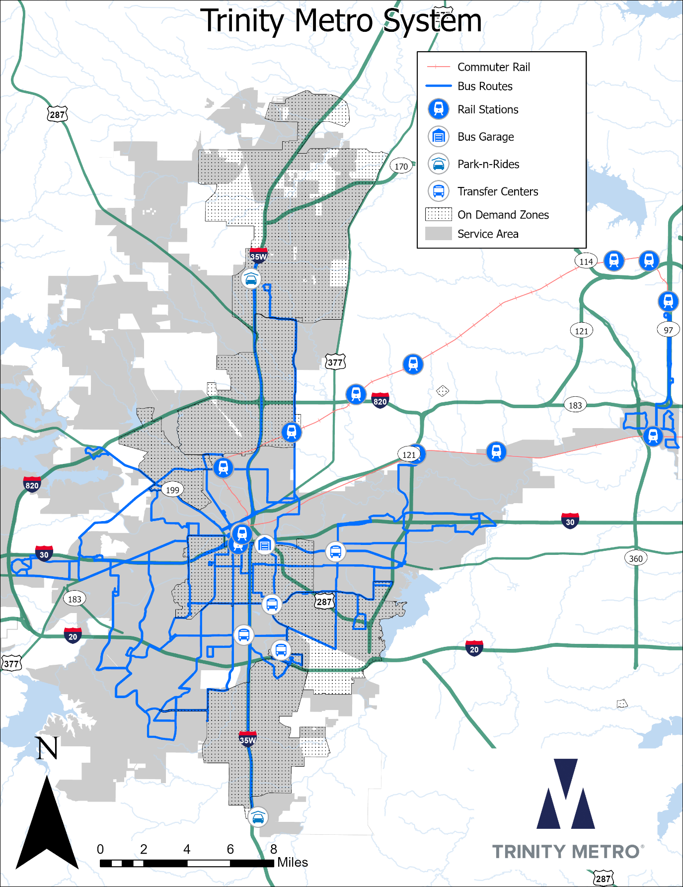

Trinity Metro Plans & Programs

Public Participation Plan
Trinity Metro has developed a revised Public Participation Plan to encourage and guide public involvement efforts. The public participation plan describes the overall goals, guiding principles and outreach methods used to solicit input regarding service changes, fare increases and capital projects from minority and low-income passengers. This plan initially grew out of the COVID-19 pandemic of 2020 to 2022 when in-person public meetings were briefly banned under the emergency authority of the Governor and County Judge. Local governments and agencies all struggled to find new ways to reach constituents. Means to conduct meetings and solicit feedback online were largely more successful than traditional methods.

Since the conclusion of the pandemic, Trinity Metro has at times struggled to attract attendance at public meetings. Previously, there were concerns that the poorest in the community lack internet access; however, recent surveys show that this is no longer a major issue. As a result, Trinity Metro will do more to ensure that the meetings are available to those who cannot attend in person. The content of the new Public Participation Plan is included as an Attachment.

Language Assistance
Due to the large number of Spanish speakers in the service area, many materials are provided in Spanish including:
- Trinity Metro Rider Guide describing instructions for riding, fare information and rules of conduct.
- Access Paratransit Service Brochure
- Notices of public meetings, service changes, major detours or changes to holiday hours.

Trinity Metro has bilingual employees who are representative of the broader community in front-line roles. Additionally, Trinity Metro contracts with Interpreters Unlimited for telephone interpretation, in-person interpretation and written translation services.

Title VI Program
This document contains Trinity Metro’s 2023-2026 Title VI Program. The program was subjected to public review and authorized by the Board of Directors on January, 20, 2026.

Notice to the Public
To make Trinity Metro’s riders aware of its commitment to the Title VI compliance, and of their right to file a civil rights complaint, Trinity Metro has presented a “Notice of Beneficiaries of Protection Under Title VI and LEP Notice” in both English and Spanish, on its buses and on posters at their administration and operation facilities.

Civil Rights
Trinity Metro is committed to ensuring that no person is excluded from participation in, or denied the benefits of its services on the basis of race, color or national origin as protected by Title VI of the Civil Rights Act of 1964, as amended. If a person believes he or she has been subjected to discrimination under Title VI, he or she may file a written complaint with Trinity Metro within 180 days from the date of the alleged discrimination.

Procedures for Filing a Discrimination Complaint
Trinity Metro has established a process for individuals to file a complaint under Title VI. Any person who believes that she or he has been discriminated against on the basis of race, color, or national origin by Trinity Metro may file a Title VI complaint by using the agency’s Title VI Complaint process. Instructions are available at Trinity Metro’s administrative offices or on their website at www.ridetrinitymetro.org.
Below is a description of the Title VI complaint process:
As a member of the general public if you desire to file a discrimination complaint under Title VI, the following procedure should be followed:
The complaint should be filed with: Detra Whitmore, Vice President of Community Engagement, People & Culture Officer, 801 Grove Street, Fort Worth, TX 76102.
- Any person who believes he or she has been subjected to unlawful discrimination may directly file a complaint or use an authorized representative.
- The complaint should, at a minimum, include the following information:
  - Complainants’ name and address, a telephone number where you may be reached during business hours
  - A general description of the person(s) or class of persons injured by the alleged discriminatory act(s)
  - A description of the alleged discriminatory act(s) in sufficient detail to enable investigator(s) to understand what occurred, when it occurred, and the basis of the alleged discrimination complaint (race, color, or national origin)
  - The letter must be signed and dated by the person filing the complaint or by someone authorized to do so on his/her behalf

The Procedure for Investigation Process
Trinity Metro investigates complaints received no more than 180 days after receipt of notice of the alleged incident. Trinity Metro will process complaints that are complete. Once the complaint is received, Trinity Metro will review it and the complainant will receive an acknowledgement letter or email informing them whether the complaint will be investigated by Trinity Metro.
Trinity Metro has up to ninety (90) days to respond to a complaint. If more information is needed to resolve the case, Trinity Metro may contact the complainant. The complainant has thirty (30) days from the date of the letter to send requested information to the investigator assigned to the case.
If Trinity Metro’s investigator is not contacted by the complainant or does not receive the additional information within thirty (30) days, Trinity Metro can administratively close the case. A case can also be administratively closed if the complainant no longer wishes to pursue their case.
After the investigator reviews the complaint, one of two letters will be issued to the complainant: a closure letter or a letter of finding (LOF). A closure letter (1) summarizes the allegations; (2) states that there was not a Title VI violation; and (3) states that the case will be closed. A LOF summarizes the allegations and the interviews regarding the alleged incident, and explains whether any disciplinary action, additional training of staff members, or other action will occur. If the complainant wishes to appeal the decision, she/he has ten (10) days after the date of the closure letter or the LOF to do so.
A person may also file a complaint directly with the Federal Transit Administration, at:
Federal Transit Administration
Office of Civil Rights
1200 New Jersey Avenue SE
Washington, DC 20590

Modes of Service
Trinity Metro operates fixed route services, Mobility on Demand known as On-Demand, and two Commuter Rails, TEXRail and Trinity Railway Express. In addition, the agency operates paratransit services, vanpool services and bike sharing.

Local fixed route service is defined as bus service that runs within shared public right of way along a specified path on a specified frequency. (The frequency varies from 7 minutes to 90 minutes.)

Mobility on Demand service branded On-Demand is designed to transport passengers to and from a point or station along a fixed route alignment, providing first and last mile service to passengers from an origin or destination beyond the ¼ mile walking distance of service within the service area using shared rides and smaller vehicles.

Trinity Metro jointly operates commuter rail service with Dallas Area Rapid Transit (DART) under contract with Herzog. This service is branded as Trinity Railway Express (TRE), travelling between Fort Worth and Dallas with ten total stations.

Trinity Metro also operates TEXRail, a 27 mile commuter rail line that extends from downtown Fort Worth, across northeast Tarrant County, through North Richland Hills and Grapevine terminating at DFW International Airport’s Terminal B.

Federal law requires transit agencies to provide paratransit service within ¾ mile of a bus route in recognition of the difficulty that disabled people face in comparison to the average able-bodied person who could walk ¾ mile. Trinity Metro provides paratransit service well beyond this minimum, to the boundary of the taxing authority. Branded On-Demand Paratransit, the agency provides wheelchair accessible vans door-to-door on pre-scheduled appointments.

Vanpool service is provided throughout the North Texas region for regular commute trips starting and/or ending in the Dallas/Fort Worth metropolitan area. Trinity Metro provides the vans, insurance, maintenance and fuel and the group riding together designate a driver and alternate driver among themselves.

Bike share provides bicycles available for check out from kiosks/stations situated next to and in the areas adjacent to train stations and transfer centers. This enables connections a little further than the traditional walkshed as well as quicker travel between points within a larger urban center.

Service Standards & Policies
Trinity Metro has developed a set of quantifiable service standards which were updated in 2025 through an internal and public participation process. The process initiated with the input of Trinity Metro’s Route Monitoring Committee (RMC) – a committee of Trinity Metro planning, scheduling and operations staff. Trinity Metro management staff then provided input in review.

In pursuit of its public mission, and the relevant statutes of Title VI (49 CFR, section 21.5), Trinity Metro also sets and maintains these service standards to ensure agency activities – whether isolated incidents or longer-term policies and expenditures – do not place a disparate impact or disproportionate burden onto the community’s minority or low-income populations.

Following the internal updating of these standards, Trinity Metro advertised and held a public information session to receive comments on the proposed standards. During the session, Trinity Metro staff presented an overview of the components of Trinity Metro’s public participation process as well as the various standards.

The content of the program was approved and adopted by Trinity Metro Board of Directors at the January 2026 board meeting.

These service standards include:

- Definition of Service Categories
- Vehicle Load
- Headway (Frequencies)
- On-time Performance (Schedule Adherence)
- Service Availability
- Service Span
- Vehicle Assignment
- Distribution of Transit Amenities
  - Bench & Shelter Placement
  - Bus Stop Layout
  - Park & Ride Stations
  - Commuter Rail Stations
- Key Performance Indicators
These are statistical standards both described and assessed under the section 2023-2025 Title VI Assessment.
Policies include:
- Service Change Process
- Major Service Change Policy
- Fare Change Evaluation Process
- Security

Service Change Process
Service Changes happen generally two to three times a year in the winter, summer & and fall. In order to assure consistency and proper planning for changes within the service area, steps are utilized for fixed-route service changes at Trinity Metro. Each service change takes approximately six months to complete.
In order to comply with 49 CFR Section 21.5(b)(2), 49 CFR Section 21.5(b)(7) and Appendix C to 49 CFR part 21, Trinity Metro shall evaluate significant system-wide service changes and proposed improvements at the planning and programming stages to determine whether those changes have a discriminatory impact.
In order to assure consistency and proper planning for changes within the service area, the following steps are utilized for fixed-route service changes at Trinity Metro. Each service change takes approximately six months to complete.
- Planning Review Proposals for Changes
  - Planning and Development reviews input from Operations, Customer Care, community, and passengers throughout the year. At this stage of the process each request will be evaluated as to feasibility, efficiency, and necessity.
- Conduct Title VI analysis for major service changes (See description of process below)
- Prepare Draft Proposals
  - Maps
  - Schedules
  - Cost Estimates
- Interdepartmental Staff Coordination Meeting
  - Operations, Planning, Scheduling, Marketing and Finance meet bi-weekly to review proposals
  - Senior management approves proposals
- Conduct Field Checks
  - Safety and Operations evaluation for turns and maneuvers.
  - Scheduling tests runtimes for schedule/timepoint verification.
- Hold Community and, or Public Hearings, if necessary for major changes.
- Board Approval, if necessary for major changes
- Route Implementation Orders distributed to staff
- Finalize Schedules (six week process)
  - Scheduler builds schedules in scheduling software.
  - Scheduler blocks bus assignments
  - Scheduler creates runs and rosters of work assignments for bus operators
- Operator Sign Up
  - Rosters are posted for bus operators consideration
  - Operators choose their work assignments based on order of seniority.
- Operator Route Guides updated
- Operator Training initiated
- Bus Stop Placement/Removal Procedures initiated
- Brief Customer Service Representatives
- Public Notice of Changes
  - Notice Posted to Web Site and onboard vehicles two to three weeks in advance
  - New schedule brochures distributed a week in advance.
  - Some major changes may need additional public outreach. Trinity Metro Staff may distribute information to customers at key boarding locations the week before, on or after implementation.
- Implement Service Change

Major Service Change Policy
This policy establishes a threshold for when a proposed service increase or decrease is “major,” and thus must be subject to a Title VI Equity Analysis and a public hearing held. The initial 12 months following implementation of a new route or a change to a route are automatically considered a pilot and the new route may be discontinued or the change reversed between 12 and 24 months if it fails to meet expectations. After 24 months, a route or change to a route is considered permanent and is subject to the Major Service Change Policy.
Only services which are fully funded by Trinity Metro member cities or federal grants are subject to the Major Service Change Policy. Services which are funded wholly or in part by Tarrant County, non-member cities, other government agencies, non-profit entities or private entities are not subject to the Major Service Change Policy and may be modified or eliminated based on the terms of the contract or interlocal agreement. They may also be eliminated for non-payment or other breach of the terms of the contract or interlocal agreement. Such changes may be subject to a public hearing by the funding partner depending on the funding partner’s charter or governing regulations.
Trinity Metro defines a major service change as:
- A decrease or increase of 25% or more of the number of transit revenue vehicle miles of a transit route, computed daily, for the day of the week for which the change is made.
- A decrease or increase of 25% or more of the number of transit revenue vehicle hours of a transit route, computed daily, for the day of the week for which the change is made.
- A modification of the path of a transit route involving 25% or more of the existing linear one-way miles.
- The elimination of an existing transit route.
- The establishment of a new transit route along streets which are not currently being served.
Mobility on Demand services are not measured in terms of revenue vehicle miles or hours. Instead, a major change will be defined as:
- A 25% or more decrease or increase in the geographic area (square miles) served.
- A 25% or more decrease or increase in the span of service (ending time minus start time) for the day of the week for which the change is made.
- A modification of the boundaries involving 25% or more of the existing geographic area served.
- The elimination of an existing Mobility on Demand service.
- The establishment of a Mobility on Demand service in a geographic area which is not currently being served.

Title VI Equity Analysis
Trinity Metro is committed to ensuring that no person is excluded or denied benefits of services based on race, color or nation origin and, as such, Trinity Metro’s service standards meet the requirements of 49 CFR Section 21.5. The following Disparate Impact and Disproportionate Burden policies are established for analysis and consideration of major service changes.

Disparate Impact Policy
The Disparate Impact Policy establishes a threshold for determining whether proposed fare or major service changes have a disproportionally adverse effect on minority populations relative to non-minority populations on the basis of race, ethnicity or national origin.
The threshold is the difference between the burdens borne by, or benefits experienced by, minority populations compared to non-minority populations. Exceeding the threshold means either that a fare or major service change negatively impacts minority populations more than non-minority populations or that the change benefits non-minority populations more than minority populations. A change with disparate impacts that exceeds the threshold may be adopted (a) if there is substantial legitimate justification for the change, (b) if no other alternatives exist that would serve the same legitimate objectives but with less disproportionate effects on the basis of race, color or national origin or c) if the prescribed analysis methodology (which is based entirely on adjacent residential population characteristics) omits critical information about the benefits to minority passengers.
Trinity Metro establishes that a fare change, major service change or other policy has a disparate impact if the minority populations will experience 20% more of the cumulative burden, or experience 20% less of the cumulative benefit, relative to the non-minority populations, unless (a) there is substantial legitimate justification for the change, (b) no other alternatives exist that would serve the same legitimate objectives but with less disparate effects or c) additional benefits to minority passengers can be documented that are not considered in the prescribed analysis methodology.

Disproportionate Burden Policy
The Disproportionate Burden Policy establishes a threshold for determining whether proposed fare or major service changes have a disproportionately adverse effect on low-income populations relative to non-low-income populations.
The threshold is the difference between the burdens borne by, and benefits experienced by, low-income populations compared to non-low-income populations. Exceeding the threshold means either that a fare or service change negatively impacts low-income populations, or that the change benefits non-low-income populations more than low-income populations. If the threshold is exceeded, Trinity Metro must avoid, minimize or mitigate impacts where practicable.
Trinity Metro establishes that a fare change, major service change or other policy has a disproportionate burden if low-income populations will experience 20% more of the cumulative burden, or experience 20% less of the cumulative benefit, relative to non-low-income populations unless (a) there is substantial legitimate justification for the change, (b) no other alternatives exist that would serve the same legitimate objectives but with less disproportionate effects or c) additional benefits to low-income passengers can be documented that are not considered in the prescribed analysis methodology.

Title VI Service Change Equity Analysis Methodology
Beginning with the August 2018 service change, Trinity Metro uses REMIX cloud-based computing for Title VI service change equity analysis. REMIX generates a Title VI report (based on Census data) by comparing existing service to a set of proposed changes. The following methodology and data sources are used when generating this report as of this writing.
Data sources
- Census data is provided by the US American Community Survey five-year estimates.
- Population is coded by table B03002, field B03002001.
- Low income status is set at 100% of the US poverty level. This is coded by the appropriate fields in table C17002.
- Minority status is coded by table B03002, by subtracting the white, non-Hispanic population (B03002003) from the total population (B03002001).
Methodology
1. Determine affected population, including low income and minority percentage.
- For each route, build a shape that represents the area within quarter mile of any of its stops.
- Intersect the catchment area with ACS Census data. Get a list of block groups and the percentage overlap with each.
- For each block group, take the percentage of overlap and multiply it by the block group’s statistics.
- Get the population, minority population, and low income population for each group and sum them together. This is the total population a route could serve.

2. Compare the number of people-trips, before and after.
- Multiply the population near a route times the number of trips it makes (per year) to get “people-trips”.
- Repeat for low-income and minority populations to get “low income people-trips” and “minority people trips”.
- Compare these numbers between the before and after versions of the route, to get a set of people-trip differences. REMIX matches before and after using routes that have the same name.

3. Get the total difference in people-trips across the transit system.
- Repeat the process above for every route in the transit system.
- Sum together the difference in people trips. This will return three numbers: total difference in people-trips, total difference in low-income people-trips, and total difference in minority people trips.

4. Calculate the change borne by low-income and minority populations.
- Divide the total difference in low-income people trips by the total difference in people-trips to get the percentage of change borne by those with low incomes.
- Repeat for minority people-trips.

5. Compare the percentage change to the average in the service area.
- Calculate the average percentage of low-income and minority populations across the entire service area.
- Subtract from the change borne by those populations.
- Get two final numbers: the delta between the impact this set of transit changes had on low income and minority populations compared to any average change.

Table 1 below shows the minority and low-income population for Trinity Metro’s service area for comparison. The Board of Directors adopted a threshold of 20% above or below the system average for determination of adverse impact.
Table 1 – Trinity Metro Service Area Population Data
Total Population of Service Area | Minority Population of Service Area | Percent Minority | Low-Income Population of Service Area | Percent Low-Income
1,044,189 | 637,287 | 61.0% | 129,052 | 12.4%

Route Improvement Plan
Should a route be determined to be performing inadequately for any reason, the following are possible actions to be included in a Route Improvement Plan on targeted low performing routes:
- Targeted marketing
- Service frequency and span changes
- Service period and service day adjustments
- Rerouting
- Rescheduling
- Elimination of nonproductive route segments
- Consolidation of segments into other routes
After implementation of a Route Improvement Plan, the route will be given twelve (12) months to move toward meeting minimal expectations. Any routes that do not achieve this performance shall be targeted for additional curtailment or elimination. In some instances, positive ridership growth trends will be sufficient to classify the route as meeting improved performance requirements.

Monitoring of Service Standards
Various Trinity Metro Departments, TRE and TEXRail Staff are responsible for monitoring and evaluating the quality and level of service on an on-going basis to assess adherence to documented service standards. These procedures will be undertaken by the following techniques:

Performance Report
A Performance Report will be generated by the Planning department using data obtained from fare boxes. This report identifies ridership levels for all modes and reports Key Performance Indicators (KPI), including Subsidy per Passenger, Passengers per Hour, Passengers per Mile. On-time Performance is determined using Automatic Vehicle Locator (AVL) systems. Trinity Metro staff, including Planning, Operations and Accounting departments, review this information to help determine general route performance and to identify routes which are developing vehicle loading concerns in need of more thorough investigation.

Customer Comments
Trinity Metro Customer Support & Solutions will record and track comments and suggestions which will be forwarded to appropriate department for response or resolution. Title VI complaints will be forwarded to the Title VI compliance officer. Comments such as vehicle loading complaints or on-time performance will be forwarded to the Operations department. Complaints regarding vehicle condition are to be forwarded to the Maintenance department. Expansion, service frequencies or stop requests will be forwarded to the Planning department.

Field Checks
Trinity Metro’s System Check Program (SCP) encourages ­ staff to become proactive in riding Trinity Metro’s buses, bikes, On-Demand and rail vehicles. This Program helps key decision makers to interact with transit users and operators and therefore creating a better understanding of our customer’s experiences and conditions. The Program also improves communications between staff and operators. Each member of staff is required to ride at least one route each month and provide a report of his or her observations.
As operational concerns surface—through information from the Performance Report, customer comments or visual inspections—a supervisor field check will be conducted. For example, if vehicle loads are being identified at excessive, an operations supervisor will be requested to conduct a load check and/or On-Time Performance to inspect the quality of operating service. Excessively over loaded routes will be relieved by placing a larger capacity bus on the route or eventually by increasing service frequency.

Boarding and Alighting
A Boarding and Alighting Study has been periodically conducted by a private contractor which provided a comprehensive and systematic review of Trinity Metro’s passenger loads and a stop-by-stop review of Trinity Metro’s system. Beginning in 2017, automatic vehicle locating (AVL) and automatic passenger counter (APC) systems were installed, and as of May 2022, 100% of the fixed route fleet are now equipped. Work is ongoing to certify the APC system for use in National Transit Database reporting. TRE is also equipped with AVL and APC systems and supplemented with manual counts by the conductor. TEXRail data is currently collected by the conductors. Conclusions arising from analysis of this data may warrant consideration of service changes

Origin-Destination Survey
The North Central Texas Council of Governments conducts a regional onboard survey every five to six years as a requirement for data collection to update the regional travel model for air quality impact assessment of proposed transportation projects. A statistically significant sample of riders is surveyed on every mode throughout the entire service span and results in a comprehensive database of passenger travel pattern information. Trinity Metro participates in the cost of this survey. Conclusions arising from analysis of this data may warrant consideration of service changes.

Public Involvement Process

Background
Public input is a requirement of the Federal Transit Administration (FTA) for all fare increases or major service reductions. Grantees must have a written process for how public comment is solicited and considered prior to raising fares or implementing major service reductions. Trinity Metro shall develop a public outreach plan that details how minority and low income individuals are encouraged to participate, however, this section shall detail the minimum actions to be taken by Trinity Metro.

Process
The public will have the opportunity to make verbal or written comments anytime Trinity Metro proposes a fare increase or major service reduction. Minimally, Trinity Metro will hold one public hearing in order to meet this requirement. In addition to holding a hearing, Trinity Metro will also notify the public of an address to which written comments may be submitted, along with other agency contact information, such as an e-mail address or phone number to be used for making a public comment. Public comment periods will commence at the time it is advertised and will be at least 10 days in length. Copies of public advertisements will be retained as part of a record of the public input process.

Public Hearing
Trinity Metro will hold a public hearing on (i) any fare change; (ii) any service change that qualifies as a major service change under the Major Service Change Policy herein. At two weeks before the date of a public hearing under the paragraph below, Trinity Metro will provide notice of the meeting time, date and location. A public hearing shall be advertised in a way that reaches the greatest number of affected parties, within reason. Examples would be postings on transit vehicles and transfer centers, email distribution for services in which Trinity Metro retains the email addresses of users, on the agency’s website and via social media channels.
For public hearings, the following procedures will be followed:
- The hearing will be recorded and transcribed by staff members of Trinity Metro
- The presentation will be streamed live over the internet or posted for subsequent viewing.
- Participants will be greeted upon arrival and will be asked to provide name and contact information for the record
- The purpose of the meeting shall be stated at the beginning of the meeting
- Staff may supply further background on why the fare or service change is being considered
- Staff shall provide instructions on procedures for making a comment at the hearing as well as providing information on how comments will be provided to decision makers
- An adequate period shall be reserved to ensure participants a reasonable opportunity to make their comments heard
- Participants shall be reminded prior to the meeting conclusion on alternative means of commenting such as in writing, by phone or at other public hearings scheduled

Consideration
Prior to the consideration of a proposed major service change, applicable decision makers shall receive a document listing all public comments received, whether written comments or verbal comments. These comments shall be considered in making a decision on the proposed fare increase or major service reduction. Additionally, Board members should be encouraged, though not required, to be in attendance at all public hearings or other public meetings addressing the topic. Finally, staff recommendations for raising fares or implementing a major service reduction should consider public comment received and—if feasible, reasonable and viable—be amended as a result.

Fare Change Evaluation Process
In order to comply with 49 CFR Section 21.5(b)(2), 49 CFR Section 21.5(b)(7) and Appendix C to 49 CFR part 21, Trinity Metro shall evaluate proposed fare changes at the planning and programming stages to determine whether those changes have a discriminatory impact.
In order to assure consistency and proper planning for changes within the service area, the following are the steps to be utilized for evaluating potential impacts to fare changes.
1) Describe the nature of the change, the bases or rationale for the change, the modes of service impacted, and the communities affected by the change.

2) Describe what are the impacts of the fare change on minority and/or low-income communities.

3) Describe what are the transit alternatives available for riders who would be impacted by proposed fare changes

a. Describe what, if any, measures Trinity Metro will take to avoid, minimize, or mitigate any adverse effects of the fare change on minority populations and/or low-income populations?
b. Describe what, if any, enhancements or offsetting benefits Trinity Metro would implement in conjunction with the fare change

4) Determine if the proposed fare change will have a disproportionately high and adverse effect on minority populations and/or low-income populations.

5) Describe what steps Trinity Metro will undertake to seek out and consider the viewpoints of minority and low-income populations in the course of conducting public outreach and involvement activities.

Title VI Fare Change Analysis Methodology
Trinity Metro does not regularly collect information on the type of fare payment used by minority and/or low-income populations. The necessary data to derive this information is normally collected in the North Central Texas Regional On-Board Transit Survey coordinated by North Central Texas Council of Governments (NCTCOG), last conducted in Fall of 2022. Supplemental surveys may be conducted as necessary to determine users of fare categories that may have been created subsequent to the last Regional On-Board Transit Survey.
The On-Board Transit Survey is used to develop Average Fare for existing ridership and to analyze the impact to riders. The major categories presented in the survey are:
(1) Travel characteristics
(2) Pass/Payment characteristics
(3) Household demographics and
(4) Rider demographics
Trinity Metro analyzes the information generated from the survey in the follow method:
- Review fares to compare rates before and after proposed change.
- Query the data to determine the number of passengers who are travelling on each existing fare media at each existing price level.
  - Minority purchasers
  - Non-minority purchasers
  - Low-Income purchasers
  - Non Low-Income purchasers
- Calculate the average fare change borne by each of the four groups and the average fare change borne by all passengers.
- Compare the increase or decrease among the groups and to the overall.

The average fare change is determined by multiplying each population group by the proposed fare change in each fare media category. Then, all average fare changes for each population group and fare media are summed and divided by the total population for the population group.

$$A=\frac{\sum_{n}{\left(M×F\right)}}{M}$$

Where:
A – Average Minority Fare Impact
M – Minority Purchasers
F – Proposed Fare Increase
n – Fare Media at each price point

The tables below shows the results for the last fare change (2024) and how the comparison is made.
Overall | Low-Income | Non Low-Income | Minority | Non-Minority | Overall
Δ Total Weekday Fares | -($1,480.16) | -($1,955.86) | -($3,713.74) | -($1,716.68) | -($5,410.33)
Total Weekday Riders | 3,841 | 4,632 | 7,629 | 4,467 | 12,096
Average Daily Fare increase | -($0.39) | -($0.42) | -($0.49) | -($0.38) | -($0.45)

 | Average Weekday Fare Decrease | Difference | Percentage Difference
All Passengers | -($0.45)
Minority | -($0.49) | -($0.04) | -9%
Low-Income | -($0.39) | $0.06 | 13%

There was No Disparate Impact or Disproportionate burden for Minority or Low-Income riders as all percentages were well within the 20% threshold.

Public Hearing
Trinity Metro will hold a public hearing on any fare change following the same process as outlined for major service changes.

Consideration
Prior to the consideration of a proposed fare increase or major service reduction, applicable decision makers shall receive a document listing all public comments received, whether written comments or verbal comments. These comments shall be considered in making a decision on the proposed fare increase or major service reduction. Additionally, Board members should be encouraged, though not required, to be in attendance at all public hearings or other public meetings addressing the topic. Finally, staff recommendations for raising fares or implementing a major service reduction should consider public comment received and—if feasible, reasonable and viable—be amended as a result.

Security
Trinity Metro currently operates its transit security policy through the implementation of a System Security and Emergency Preparedness Plan (SSEP). The SSEP outlines roles and responsibilities of all agency employees, as well as contracted security personnel. In addition to contracted physical security at the agency's critical facilities, off-duty police officers are hired to provide security at our transportation/transfer centers, on buses and commuter rail systems.
The agency also provides 24-hour video surveillance at all commuter rail stations. Primary duties of off-duty police officers are to provide police presence, as well as responding to reports of disturbances and criminal activity as needed, and targeting areas with increased levels of activity. Contracted physical security are stationed at certain facilities as an on-site deterrent; respond to and deescalating incidents as needed, monitoring video surveillance systems, as well as assisting passengers with transportation inquiries.
Security training programs have been implemented during new-hire orientations, as well as annual refresher training for all employees. Security awareness information is available to our passengers on all modes of transportation and facilities. The training programs and awareness information serves to educate all employees and passengers on observing, documenting, and reporting suspicious behavior or activity.
Trinity Metro will comply with 49 CFR Section 21.5(b)(2) and 49 CFR Section 21.5(b)(7), Appendix C to 49 CFR part 21 to supply a transit policy leading to secure and safe transit system without regard to race, color, or national origin. Security deployment of Transit Security Officers (off-duty police) generally details random and targeted riding of the commuter rail lines throughout operation, patrolling all transportation/transfer centers, and responding to calls for assistance -on buses or at bus stops- received through the bus operations communication center. Our deployment of these officers also entails addressing specific areas with higher levels of criminal activity. This is determined through incident reports received from bus operators and supervisors. Targeting specific areas will sometimes increase security presence at the intended area, while decreasing a presence at other areas with little or no activity.
Contracted security personnel are permanently assigned to two of our eleven commuter rail stations, and mobile security units are deployed to patrol and monitor other remote stations. The Fort Worth Central and T&P Stations provide an array of business amenities (public events, food services, other transportation needs, etc.) and, therefore, are more likely to be a greater terrorist risk than the other stations which provide 'park-n-ride' only services. As a result, physical security at these locations is operated full time, 24-hours a day.

2023 – 2025 TITLE VI ASSESSMENT

Minority and Low-Income Populations

Minority Population Defined
A minority is defined as a person who identified himself as Hispanic or a member of a race other than White. Census tracts have been classified as a minority tract if the percentage of the population identified as a minority in that tract is greater than the 61.0% of the population identified as minority in Trinity Metro service area as a whole. The map on the previous page labeled “Minority Census Tracts” shows Trinity Metro services and facilities with census tracts classified as either minority or non-minority. The vast majority of routes and facilities are located in minority census tracts. The table below shows the absolute number and percentage of the population identified as various racial categories and the Hispanic ethnic group for each of the member cities within Trinity Metro service area.
Trinity Metro Service Area Racial Demographic Table
 | Total Service Area
 | Number | Percent
Total Population | 1,014,376 | 100.0%
Hispanic or Latino of any race | 357,118 | 35.2%
White | 362,277 | 35.7%
Black or African American | 191,614 | 18.9%
American Indian or Alaska Native | 1,530 | 0.2%
Asian | 53,289 | 5.3%
Native Hawaiian or Pacific Islander | 1,029 | 0.1%
Some Other Race | 7,049 | 0.7%
Two or more races | 40,470 | 4.0%
Source: American Community Survey 2024 1-year Estimates (Table B03002)

Minority Routes Defined
A bus route is classified as a minority route if 1/3 of the linear miles (33%) pass through or adjacent to a minority census tract. Mileage excludes “closed door” segments where the bus will not stop such as express along freeway main lanes and segments passing through non-member cities. Table below, labeled as “Minority and Low Income Classification of Bus Routes”, lists each bus route classified as either minority or non-minority. The majority of bus routes are considered minority bus routes. It should be noted that even most non-minority bus routes connect minorities to jobs, schools and critical medical facilities in non-minority census tracts.

Minority Census Tracts Map
The map on the next page, labeled “Minority Census Tracts” shows minority and non-minority census tracts with Trinity Metro Bus Routes map overlay.
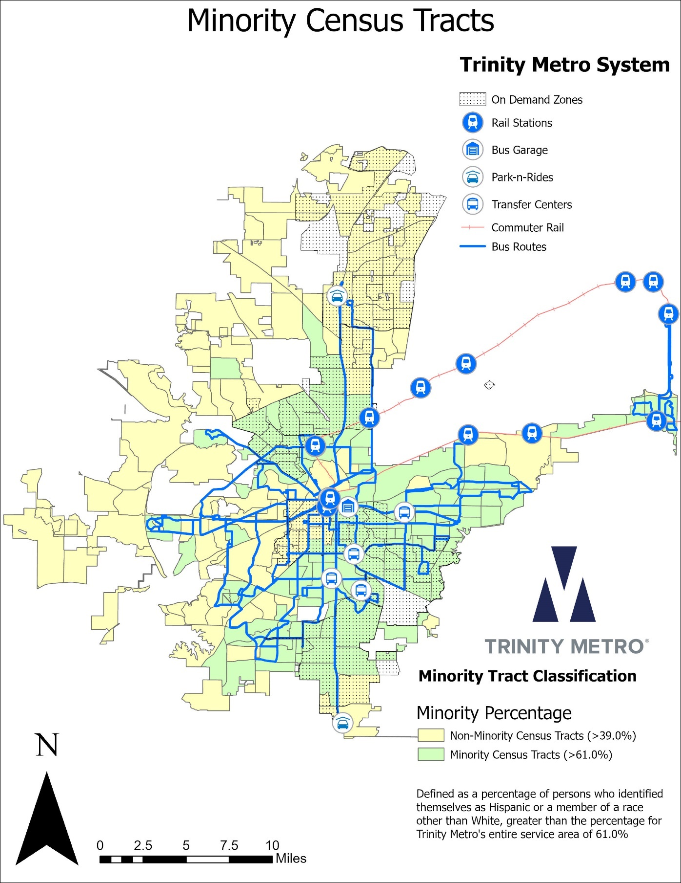

Low-Income Population Defined
A low-income person is defined as a person living in a household with income below the poverty threshold as established and reported by the U.S Census Bureau. Census tracts have been classified as a low-income tract if the percentage of the population identified as a low-income in that tract is greater than the 12.4% of the population identified as low-income in Trinity Metro service area as a whole. The map on the previous page, labeled “Low Income Census Tracts”, shows Trinity Metro services and facilities overlay of census tracts classified as either low-income or non-low-income. The majority of routes and facilities are located in low-income census tracts. The table below shows the absolute number and percentage of the population identified as low-income for each of the member cities within Trinity Metro service area.
Income Populations within Trinity Metro’s Service area
 | Total Service Area
 | Number | Percent
Population for whom Poverty Status is Determined | 923,267 | 88.4%
Persons Below Poverty | 129,052 | 12.9%
Total Population | 1,044,052 | 100%
Source: 2023 ACS 5-Year Estimates Table S1701

Low-income Routes Defined
A bus route is classified as a low-income route if 1/3 of the linear miles (33%) pass through or adjacent to a low-income census tract. Mileage excludes “closed door” segments where the bus will not stop such as express along freeway main lanes and segments passing through non-member cities. The following table lists each bus route classified as either low-income or not low-income. The vast majority of bus routes are considered low-income bus routes. It should be noted that even most non-low-income bus routes connect low-income persons to jobs, schools and critical medical facilities in non-low-income census tracts.

Low-Income Census Tracts Map
The map on the following page, labeled “Low Income Census Tracts” shows low-income and non-low-income census tracts with Trinity Metro Bus Routes map overlay.
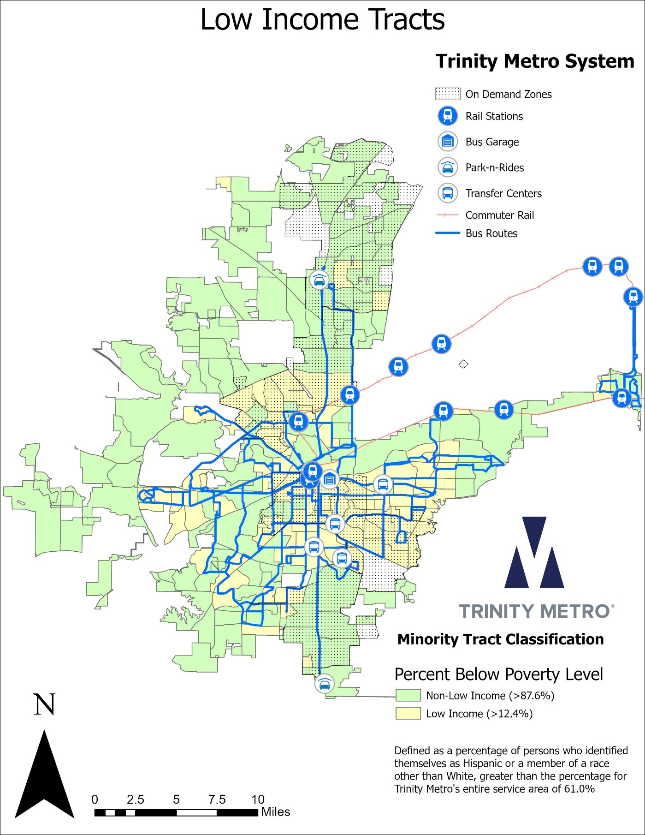

Table: Minority and Low-Income Classification of Bus Routes
Route Number | Round Trip Miles | Open Door Miles | Minority Tract Miles | Minority Class | Low Income Tract Miles | Income Class
1 | 11.56 | 11.56 | 4.98 | Minority | 8.84 | Low Income
2 | 20.63 | 20.63 | 2.46 | Non-minority | 11.75 | Low Income
4 | 18.44 | 18.44 | 14.77 | Minority | 18.13 | Low Income
5 | 21.09 | 21.09 | 17.44 | Minority | 18.78 | Low Income
6 | 23.75 | 23.75 | 13.12 | Minority | 11.79 | Low Income
11 | 13.86 | 10.80 | 7.68 | Minority | 2.10 | Non-Low Income
15 | 10.06 | 10.06 | 5.56 | Minority | 3.42 | Low Income
16 | 16.15 | 16.15 | 3.03 | Non-minority | 3.05 | Non-Low Income
19 | 1.97 | 1.97 | 0.00 | Non-minority | 0.00 | Non-Low Income
21 | 17.29 | 17.29 | 15.17 | Minority | 9.34 | Low Income
22 | 16.30 | 16.30 | 16.19 | Minority | 7.72 | Low Income
24 | 16.80 | 16.80 | 14.96 | Minority | 16.77 | Low Income
25 | 17.54 | 17.54 | 17.54 | Minority | 16.30 | Low Income
29 | 11.67 | 11.67 | 11.19 | Minority | 7.04 | Low Income
30 | 27.18 | 27.18 | 27.18 | Minority | 1.64 | Non-Low Income
31 | 6.24 | 6.24 | 4.56 | Minority | 0.00 | Non-Low Income
33 | 15.58 | 15.58 | 15.58 | Minority | 10.69 | Low Income
46 | 13.38 | 13.38 | 8.95 | Minority | 7.81 | Low Income
51 | 20.05 | 20.05 | 7.79 | Minority | 7.02 | Low Income
52 | 29.89 | 29.89 | 10.74 | Minority | 10.44 | Low Income
53 | 22.21 | 22.21 | 5.26 | Non-minority | 11.29 | Low Income
54 | 22.62 | 22.62 | 19.88 | Minority | 13.29 | Low Income
55 | 24.05 | 24.05 | 22.16 | Minority | 19.54 | Low Income
61 | 24.77 | 13.09 | 5.14 | Minority | 10.82 | Low Income
63 | 27.53 | 6.03 | 0.00 | Non-minority | 0.00 | Non-Low Income
65 | 27.67 | 5.91 | 2.97 | Minority | 0.15 | Non-Low Income
72 | 13.37 | 13.37 | 13.37 | Minority | 9.85 | Low Income
89 | 14.14 | 14.14 | 12.94 | Minority | 10.85 | Low Income
91 | 27.10 | 22.88 | 13.54 | Minority | 17.99 | Low Income
113 | 1.32 | 1.32 | 0.00 | Non-minority | 0.25 | Non-Low Income
991 | 2.14 | 2.14 | 0.00 | Non-minority | 0.00 | Non-Low Income

Assessment of Minority and Low Income Populations
Twenty-four of Trinity Metro’s 31 routes (77%) were classified as “Minority Routes” and 22 of the 31 routes (71%) were identified as “Low income” routes. Only five routes were both non-minority and non-low income under Census tract evaluation methodology and of those only one is a regular route. Route 991 is the “Juror Shuttle” which is funded entirely by Tarrant County, specifically to take jurors from a remote parking lot where jurors may park for free to the various court buildings downtown and while it’s open for anyone to ride, it very rarely functions as part of the bus network for low-income people without cars. Additionally, Routes 19 and 113, which are the “Blue Line” and “Burnet Lunch Line” operate entirely within Downtown. Route 63 is an express route designed in combination with first/last mile service to connect the inner-city residents to warehouse jobs in a suburban part of Fort Worth. The assessments of Trinity Metro’s Service Standards were evaluated with a focus on the impacts on minority and low-income populations.

Analysis of 2023 – 2025 Operation

Route Classification
In the system redesign implemented in September 2021, route categorization was standardized by frequency because that is how passengers see them. The general public is not concerned with radials, feeders or other technical criteria but frequency is easy to understand and easier for the agency to manage. Routes are color-coded on the system map by frequency for easy identification. There are only four routes (Juror Shuttle, Blue Line, Burnet Plaza Lunch Line, Orange Line) not standardized by frequency. The first three of which are subsidized through interlocal agreements with other entities or agencies, but open to all riders for free.
- High Frequency service operates with buses passing each stop along the route every fifteen minutes on weekdays during normal business hours when most people are working, travelling to medical appointments or conducting other personal business as well as shopping and recreational activities. Frequency may be reduced to half hourly early in the morning, late at night, and on weekends.

- Medium Frequency service operates with buses passing each stop along the route every thirty minutes on weekdays during normal business hours when most people are working, travelling to medical appointments or conducting other personal business as well as shopping and recreational activities. Frequency may be reduced to hourly early in the morning and late at night.

- Medium Weekday Frequency service operates with buses passing each stop along the route every thirty minutes on weekdays during the morning and evening rush when many people are commuting to work as well as travelling to medical appointments or conducting other personal business, shopping and recreational activities. Frequency is reduced to hourly during the middle of the workday in most cases, and on weekends in all cases.

- Low Frequency service operates with buses passing each stop along the route every sixty minutes on weekdays.

- Specialty Routes serve unique geographical needs and are not classified by their frequency. These routes usually provide access to niche/specific markets such as universities, entertainment districts, business parks, airports, central business district or other attractions and typically contain variable and flexible service based on a unique situation.

- Express service typically attracts riders who prefer the modal transit option to a daily commute by automobile. It provides service with a limited number of stops and generally operates on freeways. Many only operate two or three trips at uneven intervals.
These specialty routes could be considered high frequency, however, their days and spans of service cater to specific needs. It is only coincidental that these specialty routes run in Downtown, which have not only low minority populations, but small nighttime residential populations as well. These specialty routes are thus technically classified as non-minority based on geography, however that does not necessarily represent the ridership on these routes fairly.
The Juror Shuttle provides transportation between the County Courts complex and a free, remote parking lot and is paid for entirely by Tarrant County. The Juror Shuttle riders were composed of 43% minority as according to the Fall 2022 NCTCOG Origin-Destination survey would be expected to consist of jurors mostly driving in from the suburbs, but clearly it is not an exclusive service.
The Burnett Plaza Lunch Line provides a link between a complex of office buildings on the fringe of downtown and Sundance Square during lunch hours only and is paid for by the building management. There was only one passenger surveyed on the Burnett Plaza Lunch Line, insufficient to determine the demographic profile of the route, however, Burnett Plaza is home to a number of federal government agency offices including the Department of Housing and Urban Development, General Services Administration and Drug Enforcement Agency. The Burnett Plaza bus stop is also adjacent the Eldon B. Mahon US Courthouse which houses the Texas Northern District Court. With so many Federal agencies on the Burnett Plaza Lunch Line, it serves a significant number of minority employees and citizens.
The Blue Line is a tourist-oriented circulator in Downtown, and is subsidized by the City of Fort Worth, Visit Fort Worth (formerly Convention and Visitors Bureau), and participating businesses. The Blue Line, known as Molly the Trolley before June 2025, circulates Downtown hotels and the Convention Center, with ridership much higher when hotel occupancy is booked for conventions or events, thus it was found to be more moderately minority at 43%, still not exclusive.
The Orange Line is also a tourist-oriented route connecting Downtown to the Stockyards and North Side Station. It replaced Route 15 in September 2024.

Load Factor Service Standard
Table: Maximum Load Factors by service type
Load factors are measured as a percent of seated capacity and monitored throughout the service span with particular attention to the morning and evening peak commute periods. It is inefficient to program a number of buses to allow everyone to have a seat during the peaks because those extra buses would be sitting idle during the off-peak hours or alternatively operated in service in the middle of the day with very few or zero passengers. Therefore the service standards allow for some standees on vehicles in the peak. Most passengers are making relatively short trips anyway and younger passengers don’t mind standing for a short ride. When standees exceed the standards below, then it triggers the agency to explore assigning/procuring larger vehicles, increasing frequency or adding routes to accommodate the increased ridership.
Route Class | Peak Hours | Off-Peak Hours
High Frequency | 125% | 100%
Medium Frequency | 125% | 100%
Medium Weekday | 125% | 100%
Low Frequency | 100% | 100%
Express | 100% | 100%
Specialty Routes | 100% | 100%
Commuter Rail | 100% | 100%
On-Demand | 100% | 100%

Load Factor Assessment
For comparison, the average peak load factor for minority identified routes compared to non-minority routes are broken by route type on tables below. Using data pulled from automatic passenger counters, an assessment of maximum load factor on all Trinity Metro routes illustrates that they operated at acceptable load ranges. Peak loads for minority routes have not exceeded the service standards anytime in the previous twelve months.
Table: Load factor by Minority and Route Classification
Peak Load Factor
Route Type | Minority |  |  | Non-Minority
Route Type | Weekday | Saturday | Sunday | Weekday | Saturday | Sunday
High Frequency | 118% | 93% | 67% | 100% | 78% | 63%
Medium Frequency | 60% | 43% | 60% | 20% | 25% | 18%
Medium Weekday | 50% | 43% | 28% | -- | -- | --
Low Frequency | 43% | 30% | 33% | 30% | 25% | 23%
Express/Limited | 28% | -- | -- | 35% | -- | --
Specialty Routes | 89% | 40% | 51% | 78% | 9% | 6%

The peak load factor for low-income identified routes compared to non-low-income routes are broken by route type on tables below. Peak load for low-income routes have not exceeded the service standards anytime in the previous twelve months.
Table: Load factor by Income and Route Classification
Peak Load Factor
Route Type | Low Income |  |  | Non-Low Income
Route Type | Weekday | Saturday | Sunday | Weekday | Saturday | Sunday
High Frequency | 118% | 93% | 67% | -- | -- | --
Medium Frequency | 60% | 43% | 25% | 55% | 25% | 60%
Medium Weekday | 50% | 43% | 28% | -- | -- | --
Low Frequency | 43% | 30% | 33% | -- | -- | --
Express/Limited | 28% | -- | -- | 35% | -- | --
Specialty Routes | 89% | 40% | 51% | 78% | 9% | 6%

Vehicle Assignment Standards
It is Trinity Metro’s policy to comply with 49 CFR Section 21.5(b) (2) and 49 CFR Section 21.5(b) (7), Appendix C to 49 CFR part 21 regarding Title VI compliancy in our assignment of vehicles.
In that regard, Trinity Metro considers several factors when assigning vehicles or commuter rail to service. For fixed route buses it includes spare ratio, load factors, service frequency, type of service, and vehicle fuel capacity. Major amenities onboard all classes of Trinity Metro vehicles such as air conditioning are similar and they only differ in equipment based on their role, such as perimeter seating in buses used on short-haul routes making frequent stops in the urban core.

Assignment of Fixed Route Buses
All buses are wheelchair passenger accessible, and air-conditioning equipped. Most of the fleet is CNG fueled, however six new electric buses operate on a new urban circulator route branded as the Blue Line, and twelve smaller 10-passenger gasoline powered vans are being used for Paratransit service. The size of the peak load in relation to frequency determine what size vehicle is assigned to the route. Large buses may be seen to be sparsely seated during the middle of the day but would likely have been assigned to have ample capacity during the AM rush. The goal of vehicle assignment is to provide comfort and maintain the minimum seated capacity shown above. On-Demand and Paratransit have a shared fleet, and some drivers can pick up passengers as either service using the same vehicle. All fixed route buses have air conditioning, are wheelchair accessible and have bicycle racks on the front.
Other criteria impacting vehicle assignments are physical or operational in nature:
- Spare Ratio – Trinity Metro utilizes a 20% spare ratio. This ensures that a state of good repair can be maintained and service made each day.
- Fuel Capacity – Trinity Metro operates a CNG fueled fleet that restricts range in some of the fleet. Bus assignment is governed by length of run, range of vehicle and refueling requirements. Vehicles are assigned as follows: runs of less than 8 hours; any vehicle based upon load factors. Runs of over 8 hours; 35’-40’ buses with larger tanks based upon load factors. Runs of over 12 hours and load factors of > than 20 are assigned 40’ buses or larger. A few 60’ articulated buses remain but will be phased out at the end of life due to a decline in ridership since purchase.
- Type of Service - The type of service is another factor in determining assignments. Express, Mobility on Demand, or specialty service typically may use specialized vehicles optimized for the type of service. For example, express service may use vehicles equipped with single doors for greater seating capacity and high drivetrain ratios for more fuel-efficient highway speeds, specialty service may use vehicles configured as rubber-tired trolleys or electric buses configured with perimeter seating for faster boarding and alighting. These routes are inspected by supervisors and are addressed by adding additional vehicles based on visual demand. The Orange and Blue Lines each have their own dedicated fleet of CNG and electric buses respectively that operate solely on those routes.
Fixed Route buses are lined up end-to-end in long rows in the order they return to the lot each evening. The operator takes the first bus in the row of the assigned type and thus is not able to choose a “favorite” as it may be blocked in by other buses or already taken. This configuration ensures that newer and older buses are randomly distributed among the routes.

Assessment of Fixed Route Bus Assignment
Changes to the vehicle assignment beyond the standards by type, fuel capacity and spare ratio are triggered when the peak vehicle loads exceed the standards. Vehicle loads have generally been well under the seated capacity since the beginning of the COVID-19 pandemic and only recently some high frequency routes have begun to approach the service standard thresholds above during events. There were no identified inadequacies regarding vehicle assignment.

Assignment of Commuter Rail Vehicles
Trinity Metro provides modern, reliable and comfortable coaches, equipped with full climate control, air-conditioning and other amenities for its commuter rail facility. All are accessible to passengers with disabilities. Each of the two rail systems operates a unique type of vehicle and there is no interchange of vehicles between them. Following are the description of the cars or coaches that are assigned and their key service standards:
  - Trinity Railway Express operates 17 Bi-Level cars, having a seating capacity of 132 to 168 seats per car. The built dates of these cars range from 1977 to 2009 and the average age of these cars are between 16-48 years. Many have been completely overhauled in recent years.
  - TEXRail operates 8 Diesel Multiple Unit (DMU) Vehicles having a seating capacity of 225 seats. The build dates of these cars range from 2018 to 2019 and the average age of each set is 7 years.

Assessment of Commuter Rail Vehicle Assignment
It is not possible to compare how the assignment of rail vehicles impacts minority and low-income passengers with the available data. However, since COVID-19 pandemic, rail passenger volume has been suppressed by changes in work habits including work-from-home and hybrid schedules and peak load factors have not been approached. The only situations creating heavy loads have been events at American Airlines Center in Dallas for which TRE runs extra “game trains” when necessary.

Vehicle Headway Service Standards
Below is the frequency of bus routes in the Trinity Metro System as shown on the route schedule brochures and System Map. These are used to calculate the average frequency, multiplying the hours of bus service on classified routes times the frequency and dividing by the span in each category. The average can deviate from the standard due to the total span of service from end-to-end or between am and pm peaks being slightly different for each route, i.e. they don’t all start and end exactly on the hour, half-hour, etc. From the resulting table, the frequency available to minority vs. non-minority and low-income vs. non-low-income routes can be assessed.
Table: Vehicle Headway by Route Classification
Route Type | Peak | Midday | Early/Late | Saturday | Sunday
Fixed Route Bus
High Frequency | 15 | 15 | 30 | 15/30 | 15/30
Medium Frequency | 30 | 30 | 60 | 30 | 30
Medium Weekday | 30 | 30/60 | 60 | 60 | 60
Low Frequency | 60 | 60 | 60 | 60 | 60
Express/Limited | N/A | N/A | N/A | N/A | N/A
Specialty Routes | N/A | N/A | N/A | N/A | N/A
Commuter Rail
TEXRail | 30 | 30 | 60 | 30/60 | 30/60
TRE | 30 | 60 | 60 | 60 | N/A

Peak = 6-9am & 3-6pm
Midday = 9am – 3pm
Night = 6pm until end of operation day
On-Demand is not measured by headway, but rather by wait time, with a goal of 15 minutes or less.

Vehicle Headway Assessment

Average Vehicle Headway Comparison – Minority Routes
For comparison, the average headway for minority identified routes compared to non-minority routes are broken down by route type on tables below.
Table: average vehicle headway by Minority and Route Classification
Route Type | Minority |  |  | Non Minority
Route Type | Weekday | Saturday | Sunday | Weekday | Saturday | Sunday
High Frequency | 19.92 | 27.04 | 26.91 | 20.40 | 21.18 | 20.63
Medium Frequency | 33.01 | 36.00 | 36.00
Medium Weekday | 43.87 | 60.00 | 60.00 | 47.42 | 60.00 | 60.00
Low Frequency | 60.00 | 60.00 | 60.00 | 60.00 | 60.00 | 60.00
Express/Limited | 36.03 | 40.00 |  | 48.00
Specialty Routes | 15.00 | 15.00 | 15.00 | 12.33 | 7.00 | 7.00

While non-minority routes generally have a shorter average headway, this is driven by the fact that there are only a small number of non-minority routes, therefore even if one is high frequency, it skews the averages considerably. The only non-minority high frequency route is Route 2 which skews the weekend in favor of non-minorities, however, while it travels through many non-minority Census tracts, the route it serves multiple purposes. Besides passing by many major art museums and through upscale shopping districts, Route 2 also connects subsidized and moderately priced rental housing on its west end to Central Station downtown as well as to jobs and grocers with fresh produce. Three out of four Specialty routes are classified as non-minority and have slightly better frequency; however, this is affected by the Blue Line at 7 minutes which only circulates a short path in downtown.

Average Headway Comparison – Low-income Routes
For comparison, the average headway for low-income identified routes compared to non-low-income routes is broken out by route type on tables below.
Table: average headway by Income and Route Classification
Route Type | Low Income |  |  | Non-Low Income
Route Type | Weekday | Saturday | Sunday | Weekday | Saturday | Sunday
High Frequency | 19.99 | 26.20 | 26.01
Medium Frequency | 33.01 | 36.00 | 36.00
Medium Weekday | 42.62 | 60.00 | 60.00 | 48.14 | 60.00 | 60.00
Low Frequency | 60.00 | 60.00 | 60.00
Express/Limited | 41.25 |  |  | 37.72 | 40.00
Specialty Routes | 15.00 | 15.00 | 15.00 | 12.33 | 7.00 | 7.00

Low Income service appears to have better frequency overall, however, it can be noted that there are only a small number of non-low income routes, therefore even if a high frequency route passes through a non-low income tract, it is still classified as a low income route. Express/Limited category includes higher frequency feeder service to DFW International Airport classified as non-low income by the demographics around the train station where it connects, but is subsidized by the airport and other partners and is primarily used by baggage handlers and terminal service workers. With the exception of the Orange Line, Specialty Routes are classified as non-low income; however, these routes are subsidized by downtown partners to promote tourism and solve air quality and congestion issues within the downtown core as those are also goals of Trinity Metro.

On-Time Performance Service Standards
On-time performance (OTP) is a measure of runs completed as scheduled. Trinity Metro’s definition of “on-time” for fixed route service is any bus that arrives between one minute before and eight minutes after the posted time point. Bus operators are instructed not to depart time points early and as that is entirely within our control, such incidences are insignificantly small.
Paratransit is pre-scheduled with passengers advised to be ready to depart within a 30 minute window, therefore, “on-time” is 15 minutes either way of the middle of the pickup window. However, paratransit customers get an automated text message when their vehicle is enroute, at 30 minutes, 15 minutes and 5 minutes away which is very reassuring but also helps maintain the schedule as they are better prepared for the vehicle arrival. On-Demand services function similarly to traditional Paratransit, just with spontaneous scheduling through a smartphone application within the zone. Additionally, the TRE and TEXRail definition of “on-time” is any train arrival within five-minutes of the posted time on the schedule and does not depart early. Goals are indicated below. Care is taken to set achievable schedules and corrective measures are taken when a service falls below the goal.
Mode | Early | Late | Goal
Fixed Route Bus | 1 min | 8 min | 90%
Paratransit (pre-booked) | 15 min | 15 min | 91%
On-Demand | 0 min | 15 min | 88%
Commuter Rail  TRE  TEXRail | 0 min  0 min | 5 min  5 min | 97%  98%

On-Time Performance Analysis
The following analysis is based on analysis of automatic vehicle location (AVL) data for all timepoints on AVL equipped vehicles for the entire month of September 2025.
Table: On-Time Performance by Minority and Route Classification
 | On-Time Performance
 | Route Type | Minority | Non-Minority
 | High Frequency | 88.40% | 83.90%
 | Medium Frequency | 85.90% | 85.40%
 | Medium Weekday | 86.90% | --
 | Low Frequency | 87.90% | 85.10%
 | Express/Limited | 87.90% | 72.90%
 | Specialty Routes | 85.30% | 74.10%
 | All | 88.40% | 83.90%
Table: On-Time Performance by Income and Route Classification
 | On-Time Performance
 | Route Type | Low Income | Non-Low Income
 | High Frequency | 87.60% | --
 | Medium Frequency | 85.10% | 88.70%
 | Medium Weekday | 86.90% | --
 | Low Frequency | 87.50% | --
 | Express/Limited | 84.30% | 83.00%
 | Specialty Routes | 85.30% | 74.10%
 | All | 86.90% | 81.10%

Overall, Minority and Low-Income routes have superior on-time performance compared to non-minority and Non-Low Income routes, with the lone exception being two interlined medium frequency routes which happen to be performing a little better than the others. In the case of Non-Low Income Specialty Routes having 74.1% OTP, this number is weighed down by the Blue Line, which does not have a set schedule, but buses are supposed to run headways seven minutes apart. Due to traffic and construction in downtown, the spacing between buses often results in bunching and spread beyond the targeted seven minutes.
Table: on-time performance by minority, Income and Route Classification
 | Fixed Route Classification
 | Minority | Non-Minority | Low Income | Non-Low Income
Percent On-Time | 87.40% | 80.80% | 86.90% | 81.10%
Percent Early/Late | 12.60% | 19.20% | 13.10% | 18.90%

Both Minority and Low Income routes experience better on-time performance than Non-Minority and Non-Low Income routes. This is partly because Non-Minority and Non-Low Income routes operate in areas with greater traffic volume and suffer from increased congestion while minority and low-income areas have lower overall density and less economic activity to generate traffic congestion.
All are equally behind the 90% goal. Planning, Scheduling and Operations staff are working diligently to find solutions to improve performance. Operations is emphasizing bus pull-out times, monitoring drivers and coaching where necessary. Scheduling is evaluating time table adjustments and Planning is working with the City of Fort Worth and the North Central Texas Council of Governments to implement Transit Signal Priority along key corridors.

Service Availability Standards
Adequate service availability is determined by access to bus stops and rail stations. The most common way of measuring availability is to estimate the population living within ¼ mile of bus stops, ½ mile of rail stations, or within an On-Demand zone, as this represents customers who would likely walk to access transit. According to the 2023 Census 5-year estimates, approximately 569,987 people out of a service area population of 1,044,189 resides within those parameters, or 54.6%. The goal of the agency is to add service to increase these percentages as funding allows and to adjust service to prevent declines to the extent possible if populations should shift without increased funding.
Allocation of resources involves a choice between geographic coverage or service frequency. The service area could have close to 80% coverage with hourly frequency or 10% coverage with fifteen-minute frequency under the same budget. The allocation is based on analysis of transit need and population density. Corridors featuring affordable apartment units for example receive higher frequency while the majority of the service area, characterized by single-family homes and sparse development patterns receive only hourly service or no service at all depending on need. Mobility-on-Demand service has been piloted in five zones, adding a great deal of coverage, particularly where density is a challenge for fixed route service. However, On-Demand has proven to be much less efficient than anticipated on a cost-per passenger basis and thus a consultant study is currently underway as of December 2025 to determine the future direction of On-Demand.
Need is assessed through allegorical Census block group statistics including population density, minority population, persons below poverty and persons who are less likely to drive alone such as youth aged 5 to 19, seniors aged 65 and over and persons in households without a car. An area may be determined to have people with these characteristics, but if there are only a small number of them and/or a bus would have to travel an unusually long distance to serve them, then service may not be cost-effective.
Census data is useful in assessing the population density and needs of residents, but it only addresses the need at home. Jobs data from the Longitudinal Employer Household Dynamics survey is also analyzed to determine where people go once they leave home. Jobs per square mile is an effective allegory for transit need where there are both employees and customers traveling for goods and service. These factors together identify where transit need is greatest. With a limited operating budget, the agency endeavors to serve as many addresses as possible with the most effective and efficient mix of modes and frequencies.

Service Availability Assessment
Service availability is evaluated by two important elements: access to bus routes and access to bus stops. Based on analysis in REMIX, a transit planning software, 306,708 people out of a service area population of 1,044,189 resides within ¼ mile of a fixed route bus stop, or 29.4%. Of these, 72.0% or 220,820 are minority and 19.1% or 56,643 are low-income. These are higher percentages than the service area as a whole at 61.0% and 12.4% respectively. The current fixed route bus system is designed to benefit minority and low-income passengers more than non-minority and non-low-income riders. Also, roughly 19,000 people, or 1.8% live within ½ mile of seven commuter rail stations that fall within the service area (there are additional commuter rail stations outside the service area operated under contract to other municipalities). Of these, 61.4% or 11,800 are minority and 15.6% or 3,000 are low-income. These also are higher percentages than the service area as a whole.
When adding the area for mobility On-Demand services and ½ mile of rail stations, the total service area population within walking distance of any kind of public transit service is 569,987 or 54.6%. Of the 569,987 people, 380,684 or 66.7% are minority which compares favorably to the 61.0% minority within the overall service area. Also, 86,157 or 15.1% are low-income which compares favorably to the 12.4% low income within the overall service area. With all modes included, a greater percentage of minorities and low-income persons have transit service within walking distance as compared to the service area population as a whole.
Transit Access Map
The map on the following page shows Trinity Metro’s service availability within the service area overlaid upon the minority census tracts.
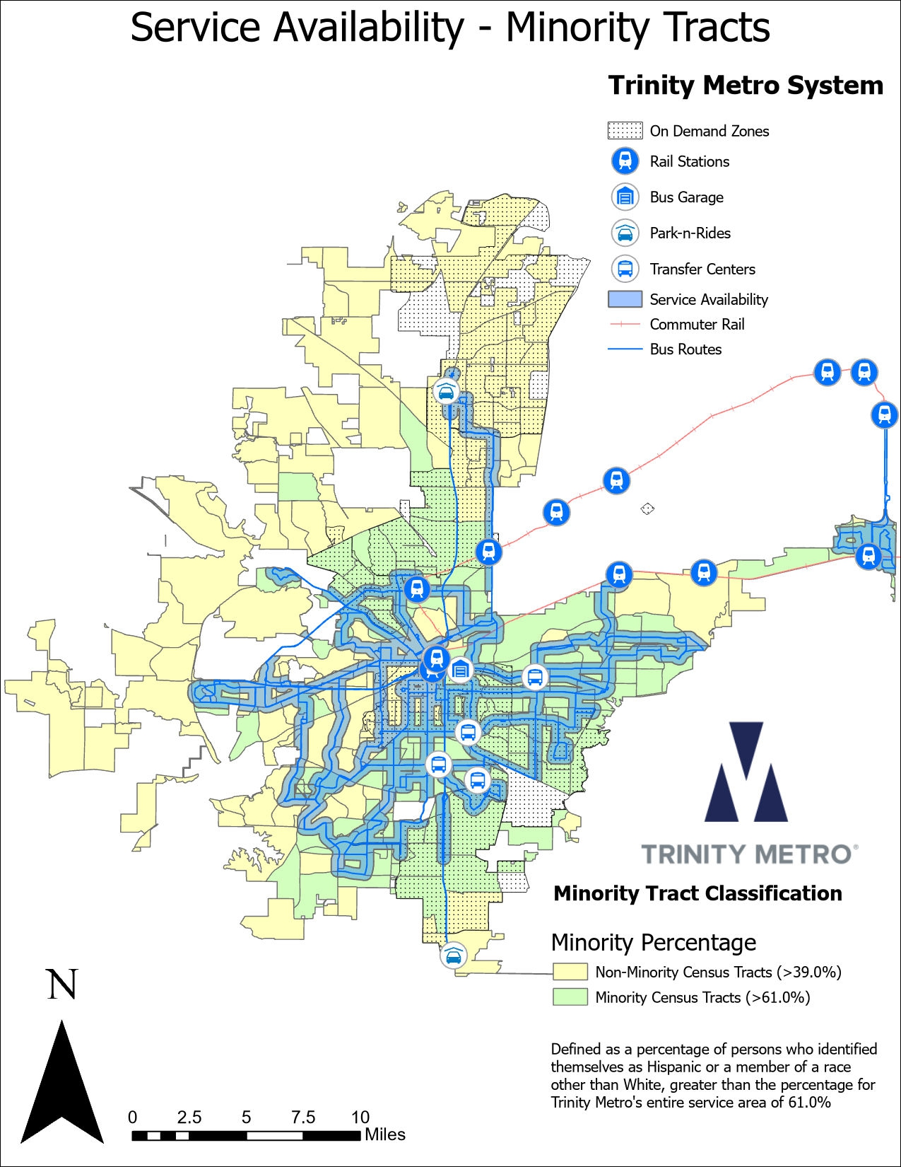

The map below shows Trinity Metro’s service availability within the service area overlaid upon the low-income census tracts.
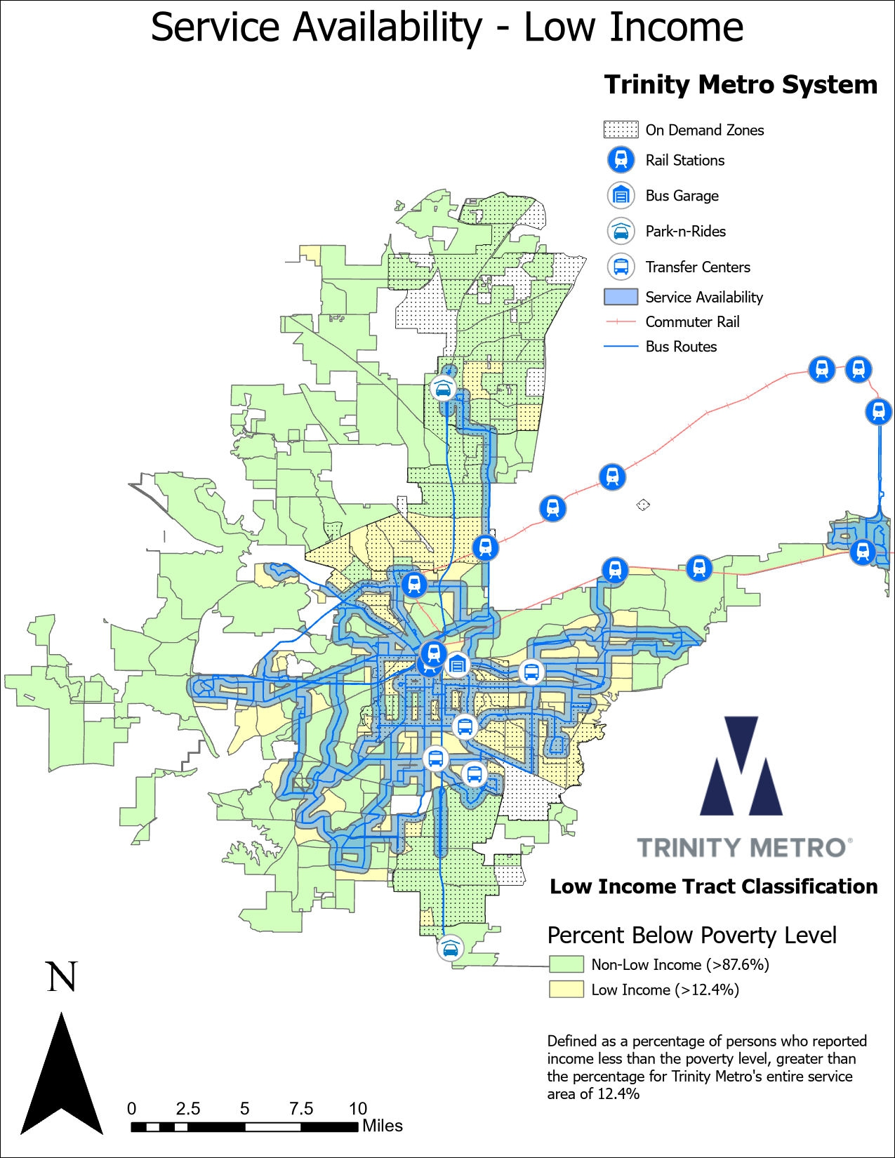

Key Performance Indicators (KPI) Standards
Key fiscal performance indicators are measured for each fixed bus route on a regular basis and compared to the systemwide averages for the previous year. These are passengers per revenue hour, passengers per revenue mile and subsidy per passenger. The systemwide averages for FY 2025, the last full fiscal year for which statistics are available are as follows:

 | Avg | Std Dv
Passengers per Mile | 0.73 | 0.49
Passengers per Hour | 8.45 | 4.87
Subsidy per Passenger | $13.20 | $8.92

New routes are given a minimum of twelve months to develop before evaluation. Performance of individual routes varies significantly due to the demographic and economic characteristics of the area served and the type of route, therefore no minimum performance levels are established which would automatically dictate the elimination of service. Each route is evaluated on its own merits. Once mature, any route that falls to less than one standard deviation of the system averages may be considered for modification. Routes that perform significantly worse than one standard deviation may be eliminated in response to declining revenues/increasing operating costs (to address a budget deficit) or to free up resources for improvements to other routes. Routes that are subsidized through public-private partnerships will not be modified or eliminated without the consent of the funding partner.
The following are possible actions to be included in a Route Improvement Plan on targeted low performing routes:
- Targeted marketing
- Service frequency changes
- Service period and service day adjustments
- Rerouting
- Rescheduling
- Elimination nonproductive route segments
- Consolidation of segments into other routes
After implementation of a Route Improvement Plan, the route will be given twelve (12) months to move toward meeting minimal expectations. Any routes that do not achieve this performance shall be targeted for additional curtailment or elimination. In some instances, positive ridership growth trends will be sufficient to continue service while monitoring improved performance requirements.

Key Performance Indicators (KPI) Assessment
KPIs for each route are calculated for comparison. The analysis for the previous fiscal year 2025 showed 9 out of 31 routes with at least one KPI outside of the theoretical normal range and only 4 routes with two or more. Having only one of three KPI’s out of range is not considered critical. 26 out of all 31 routes have a designation of either Minority or Low Income, so the fact that all 4 routes with 2 or more KPIs out of normal range are either Minority or Low Income is not extraordinary. 3 of the 5 routes that are neither Minority nor Low Income had 1 KPI out of normal range.
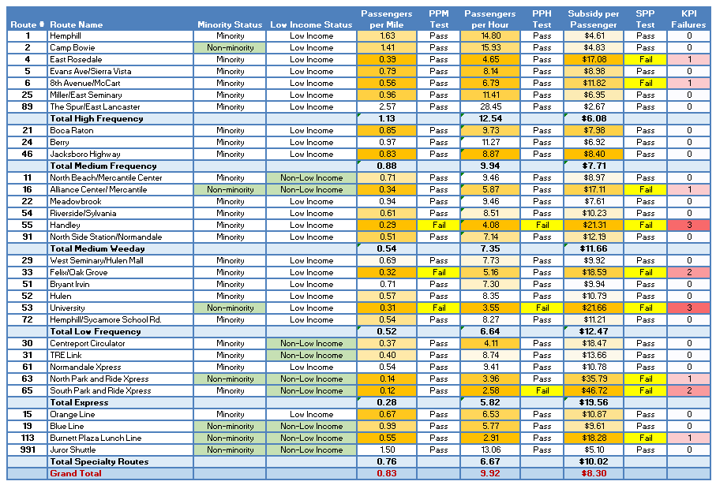
Since the redesign in September 2021, ridership increased on Trinity Metro at a faster rate than on peer transit agencies, assumably due to the benefits of the redesigned system, however there are a few routes with disappointing performance. For example, Routes 12, 23, 28, 45, 66, and The DASH were all discontinued in the last two years. Routes 4, 53, and 91 may be subject to change at a future date.

Service Span Standards
The time between the first and last trip operated on a route is the span of service on that route. It is Trinity Metro’s goal to have a consistent span of service for routes within a frequency category to maximize the opportunities for passengers to avail themselves of the connectivity of Trinity Metro’s bus service. The standard for span of service for each type of Trinity Metro fixed-route service is illustrated by the following chart, which lists the latest start time and earliest stop time. Proposed changes to one route more than an hour outside these spans would trigger a study of potential balancing changes to the other routes in the category.

Fixed Route Bus Service Span
Route Type | Weekday | Saturday | Sunday
Route Type | First Trip/Last Trip (trip start time) | First Trip/Last Trip (trip start time) | First Trip/Last Trip (trip start time)
High Frequency | 4:23 am to 12:02 am | 5:18 am to 12:02 am | 5:18 am to 11:23 pm
Medium Frequency | 5:15 am to 10:59 pm | 6:08 am to 10:53 pm | 6:08 am to 10:53 pm
Medium Weekday | 4:42 am to 11:08 pm | 5:57 am to 11:08 pm | 5:57 am to 10:05 pm
Low Frequency | 4:59 am to 10:52 pm | 5:45 am to 10:52 pm | 5:45 am to 9:52 pm
Express/Limited | 5:10 am to 11:48 pm | 5:32 am to 11:48 pm
Specialty | 4:45 am to 1:26 am | 4:45 am to 1:26 am | 4:45 am to 1:26 am
Each commuter rail is operated under its own unique set of circumstances. TRE for example is operated in partnership with another transit agency and connects to different modes in both service areas. Their current service spans are presented here for reference, but proposed changes to service span are evaluated independently of each other.

TRE Rail Service Span
Route Directions | Weekday | Saturday | Sunday
Route Directions | First Trip/Last Trip (departures) | First Trip/Last Trip (departures) | First Trip/Last Trip (departures)
Westbound Trip from Union | 5:15 am/11:50 pm | 6:35 am/12:15 am
Eastbound Trip from T&P | 4:58 am/11:58 pm | 5:48 am/12:48 am
TEXRail Service Span
Route Directions | Weekday | Saturday | Sunday
Route Directions | First Trip/Last Trip (departures) | First Trip/Last Trip (departures) | First Trip/Last Trip (departures)
Westbound Trip from Terminal B | 5:10 am/12:30 am | 5:10 am/12:30 am | 5:10 am/12:30 am
Eastbound Trip from T&P | 4:13 am/10:43 pm | 4:13 am/10:43 pm | 4:13 am/10:43 pm

Service Span Assessment
Average service span overall for fixed routes is 15 hours and 25 minutes on weekdays, 16:34 on Saturdays, and 15:49 on Sundays. Average span for minority routes is calculated by adding the total span in hours for each of the minority routes and dividing by the quantity of said routes and again for non-minority routes. Comparisons then are made to determine balance. Tables below compare service span for minority vs non-minority and low income vs non-low income routes.
Route Type | Minority |  |  | Non Minority
Route Type | Weekday | Saturday | Sunday | Weekday | Saturday | Sunday
High Frequency | 18:50 | 17:58 | 17:13 | 19:39 | 18:39 | 17:39
Medium Frequency | 16:56 | 16:09 | 16:09
Medium Weekday | 16:53 | 15:54 | 15:05 | 15:56 | 15:26 | 15:26
Low Frequency | 16:08 | 15:44 | 14:32 | 16:00 | 15:00 | 14:00
Specialty | 20:41 | 20:41 | 20:41 | 9:01 | 12:00 | 12:00
Express/  Limited | 8:29 | 18:16 |  | 16:00

Table below compares service span for Low Income vs Non-Low Income routes
Route Type | Low Income |  |  | Non-Low Income
Route Type | Weekday | Saturday | Sunday | Weekday | Saturday | Sunday
High Frequency | 18:57 | 18:04 | 17:17
Medium Frequency | 16:56 | 16:09 | 16:09
Medium Weekday | 16:36 | 15:39 | 14:54 | 16:58 | 16:09 | 15:38
Low Frequency | 16:06 | 15:36 | 14:26
Express/  Limited | 3:20 |  |  | 11:39 | 18:16
Specialty | 20:41 | 20:41 | 20:41 | 9:01 | 12:00 | 12:00

Non-low income and non-minority routes would appear to have a greater span of service although the weighted average of service spans is greater for minorities and low income because there are more of them. Minority routes actually have a much greater overall average service span of 15:43 compared to 13:22 for non-minority routes. Low Income also has a much greater overall average service span at 16:01 to 11:53 for non-low income hours. There are also some slight differences unavoidable as a function of the route length and the distance of the terminus from the central bus garage, particularly when there are so few non-minority and non-low income routes in the averages.
There is only one High Frequency route classified as Non-Minority, Route 2, which passes through the neighborhoods of Ridglea Hills and Arlington Heights although the actual ridership surveyed in the Fall of 2022 showed it to be 65% minority passengers. One express/limited route that is classified as non-low income, Route 31 TRE Link which provides service to Dallas Fort-Worth International Airport from Centreport Station and runs extremely long hours due to the 24-hour operation at the airport and connects with the TRE. While it operates through a non-low Income Census tract, it is a critical job connection for minorities and some low-wage jobs such as part-time baggage handlers. Route 31 riders are actually 59% minority. Thus the categories of High Frequency and Express Limited likely have fair service spans.
Three of the four specialty routes are financed by other agencies and partners and happen to be non-minority and non-low income as a function of being in and around downtown.

Service Standards for Amenities

Requests for Bus Stops and Amenities
Customers are able to request new bus stops along existing bus routes as well as new benches or shelters at existing bus stops. Customers can send requests via email, through Trinity Metro social media accounts, or by calling Customer Care directly. Requests for bus stops and amenities are forwarded to the Planning Department for review. Requests for benches and shelters are ranked using the criteria and points system shown below. Requests for new bus stops will be reviewed and approved or denied following the Bus Stop Placement Review process.

Bus Stop Placement and Review Process
Requests to add, remove, or relocate bus stops are reviewed through a formal process to ensure safety, accessibility, and operational performance. Important data and information regarding the existing conditions, traffic patterns, accessibility, safety and other factors around the location being reviewed are collected. Team members representing safety, security, operations, and planning departments meet onsite to review the request. Team members provide input on whether to approve or deny the request or suggest an alternate location, if possible. The customer is notified within 14 business days whether their request was approved or denied.

Bus Stop Spacing
In general, bus stops should be located in the vicinity of demonstrated or potential ridership generators. A requested location that has a projection of a minimum of five boardings or alightings per day should be considered as a candidate for a bus stop. This is determined by considering the land use of the area and/or identifying if there are key ridership generators nearby in comparison to similar conditions on existing routes. I.e. a new 10,000 square foot grocery store may be likely to generate similar ridership volume to another 10,000 sf grocery store.
To maintain an efficient flow of bus travel, spacing of bus stops is an important point to consider. In general, the land use development is the primary factor in determining the number of bus stops placed per given area. The following are general rules of thumb for spacing of bus stops:
Environment | Spacing Range | Typical Spacing
Central Core Areas of CBD’s | 300 to 1000 feet | 600 feet
Urban Areas | 500 to 1200 feet | 750 feet
Suburban Areas | 600 to 1800 feet | 1000 feet

If the route has bi-directional service, bus stops should be placed generally across the street from one-another. The bus stop for the return trip should ideally be within sight of the stop where a passenger disembarks.
Far-side stops are preferred over near-side stops at signalized intersections because they allow buses to reenter traffic more easily, there is no pedestrian crossing in front of a bus, buses do not block traffic signals, and it is less likely for the rear-end of a bus to protrude onto adjacent lanes. Far-side bus stops are located immediately after an intersection, so the bus passes through the intersection before stopping which maximizes efficiency of a route, particularly when used together with Transit Signal Priority.
ADA, utility and adjacent land uses impact bus stop location and spacing. Bus stops should be located where they are accessible from the prominent ridership generators. Lack of sidewalk, ramps or incompatible land uses may prevent even spacing.

Shelters
Passenger shelters provide seating and protection from bad weather for customers and are particularly important to senior citizens, parents with small children, and persons with disabilities. Trinity Metro also provides benches for the added convenience of its passengers. Benches are recommended at frequently used stops where the number of daily passenger boarding’s is lower than locations with shelters but higher than most standalone bus stops. An overall goal is to have both shelters and benches placed strategically to allow equal availability throughout the system.
Although shelters and benches are a popular amenity at bus stops, the associated cost of placement and maintenance allows only a limited amount possible throughout the service area. To identify locations and calculate a fair distribution method for existing amenities, a point system was established to prioritize and rank locations. The criteria and scoring system for shelter and bench placement is heavily weighted toward ridership but also considers other factors such as the number of requests and the nature of the facility served, for example a medical office building or senior center would be awarded extra points.
The qualification factors and corresponding points are listed below.
Qualification  Categories | Points
Average Daily Boardings | 1 point for each boarding
Major activity/employment center | 25
Hospital or Social Service Agency | 25
Apartment complex | 20
Elected Official Request | 20
Schools | 20
Minor Activity Center | 15
Transfer Point | 15
Joint participation (public/private) | 15
Customer Request | 1 per request
Limited Headway (midday greater than 55 minutes) | 10
Property Owner Requests | 8
As budget is allocated to purchase additional shelters and shelter maintenance, all bus stops are scored according to the criteria above. For example, if the budget for the upcoming fiscal year set aside funds for 20 new shelters, then the top 20 ranked bus stops would be recommended for installation and submitted for engineering and feasibility analysis.
A second phase visits each candidate bus stop location and evaluates for feasibility of installation. The presence of street trees, utility poles, retaining walls, slopes or other physical features may inhibit the installation of a shelter or be cost-prohibitive. The location of the proposed shelter in relation to driveways and intersections may also impair sight-distance for motorists. If a candidate bus stop location must be eliminated for any reason, the next highest ranking bus stop on the list is evaluated. This process continues until there are 20 feasible candidate locations.
The third phase is engineering. The list of 20 locations is then submitted to an engineering firm for survey and design. The engineering firm may discover unseen feasibility issues such as the presence of underground utilities below the site or the location of private property lines. If a candidate site must be eliminated during the engineering phase, the next top ranking bus stop from the list is added. The final designs for 20 feasible shelter locations are then drawn in a Computer Aided Drafting (CAD) program, printed and submitted to the City and in some cases Texas Department of Transportation (TXDOT) for permitting.
The fourth phase is permitting. The City and TXDOT review the engineer’s drawings and either approve or deny a building/construction permit. The engineer will work with the authorities to remedy any deficiencies in the design to obtain the permit. If a candidate bus stop must be eliminated during the permitting phase, the next top ranking bus stop is selected from the ranked list. The final 20 permitted shelter locations are then packaged and bids are solicited for construction.
The fifth phase is construction and assembly. A local concrete contractor is selected to construct the foundation and any additional infrastructure necessary for an ADA accessible shelter. Very often, the sidewalks, curbs, ramps and even the street itself may require modification in addition to the shelter foundation. Once the concrete work is complete, it is inspected by a Registered Accessibility Specialist and any ADA deficiencies are corrected by the contractor. Once all 20 sites are approved as completed, the shelter vendor will assemble and erect the shelters.

Benches
Trinity Metro provides benches for the added convenience of its passengers. Benches are recommended at frequently used stops and often in locations where shelter installation was not feasible. An overall goal is to have benches placed strategically to allow equal availability throughout the system.
The selection of candidate bench locations uses the same ranked criteria but is not as involved as shelter locations because they have a smaller footprint, present fewer ADA issues and are not considered a “building” for city permitting purposes (rather they are “street furniture”). As budget is allocated to the purchase of benches, the top ranked bus stops that do not have a shelter and are not being evaluated as a candidate shelter site are recommended for bench placement. For example, if the budget for the upcoming fiscal year sets aside funding for 20 new benches, then the top 20 ranked bus stops are recommended for placement and submitted for feasibility analysis and engineering. They would proceed through the same process as described for shelters above.

Bus Stop Layout
Bus stops must be designed to accommodate both disabled passengers and pedestrians. Shelters, benches, signs, trash cans (if provided), lighting, information kiosks, landscaping and street furniture shall not block access to the bus or passage along the street for any person regardless of disability. It is the policy of Trinity Metro when erecting a bus passenger shelter to remove any accessibility barriers between the shelter pad and the nearest street corner or within reasonable distance. This may include installing or repairing sidewalk, installing or repairing a curb ramp, corrective grading of slopes, utility relocations or removal of other obstructions. The placement of the shelter and other features should consider the free flow of wheelchair passengers along the street. Wherever possible, wheelchair passengers should be able to continue along the sidewalk in a straight line, however, in most locations the right of way is too narrow, therefore the concrete pad shall be of sufficient dimensions to allow passage around the facilities. Budget and cost of such improvements may prevent installation of a shelter in some challenging locations.
Bus operators are trained to stop with the front of the bus aligned with the bus stop sign post, therefore, all bus stop features should be placed to the right of the sign post as if viewed from the center of the street. All bus stops regardless of amenities must have a flat, clear zone of at least five feet wide (along the curb) by eight feet deep (measured perpendicular from back of curb) immediately to the right of the sign post for the bus to deploy its wheelchair ramp and for wheelchair passengers to roll off unobstructed.
Pads shall be sized appropriately for the size of shelter being installed. There are two sizes of shelters that can be installed based on ridership or transit center designation. Both shelters are manufactured by Tolar and come in 10’ x 6’ and 19.5’ x 6’ dimensions. The typical bus shelter size most commonly installed is 9’ x 5’9 3/16” with a footprint of 10’ x 6’. Pads shall have a slope of no more than 2% toward the street. Pads shall be a minimum of 21’ x 11’ with six inch thick 3,000psi concrete with #4 rebar on twelve-inch-centers. Sidewalk shall be four inches thick with #3 rebar on eighteen-inch centers. Pads should be sized such that the center of the footings can be placed twelve inches from the edge of pavement to minimize cracking and provide work surface for maintenance crews. Illustrations below give typical layouts and dimensions for a shelter pad based on shelter size.
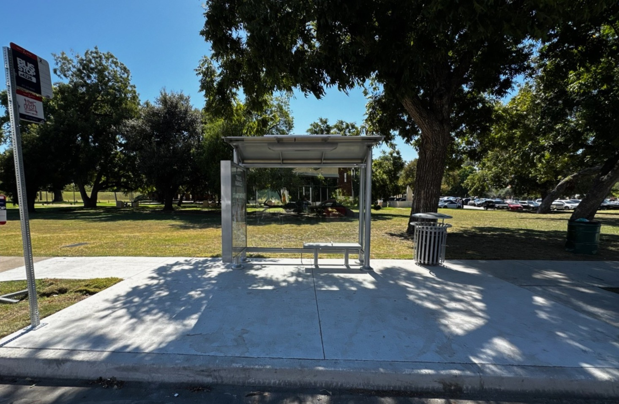Figure 1 – Typical Shelter Bus Stop Layout for 10’ Shelter
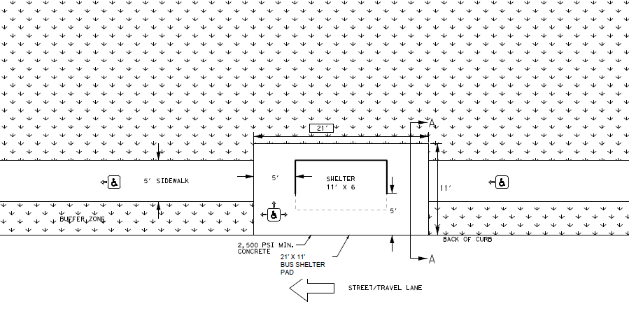
Figure 2 – Typical Pad Layout for 11’ x 6’ Bus Shelter with 21’ x 11’ Pad
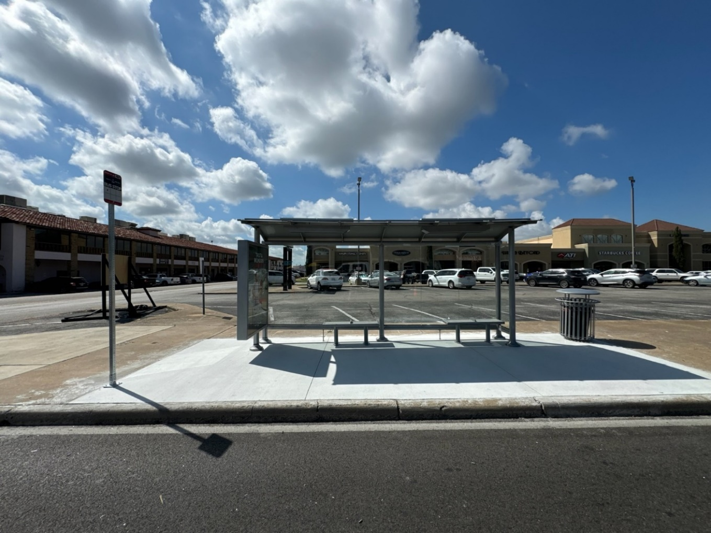
Figure 3 – Typical Shelter Bus Stop Layout for 20’ Shelter
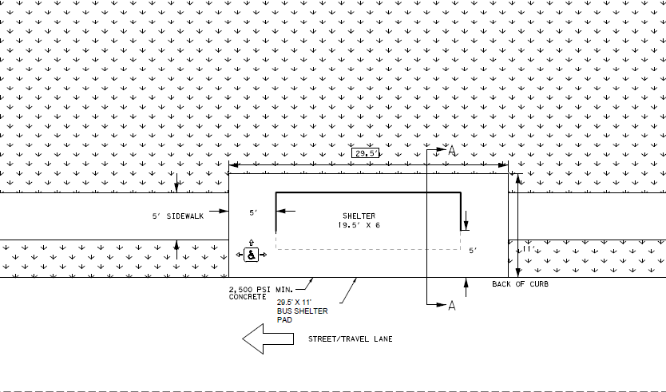
Figure 4 - Typical Pad Layout for 19.5’ x 6’ Bus Shelter with 29.5’ x 11’ Pad

Amenities Distribution Assessment
There are currently 251 shelters, 339 benches, 51 digital signs, and 186 solar lights placed throughout Trinity Metro’s service area. There is one shelter in the system (at Meacham & Gemini) with a solar light and digital sign not located at a bus stop. It previously served as a stop on Route 12 until its discontinuation, but now serves as an On-Demand stop, as it is located in the Mercantile On-Demand Zone.
Amenity distribution in Trinity Metro Service area
 | Total | Minority | Non-minority | Low-income | Non-Low-income
Shelters | 251 | 176 | 75 | 170 | 81
% of shelters |  | 70% | 30% | 68% | 32%
Benches | 339 | 191 | 148 | 214 | 125
% of Benches |  | 56% | 44% | 64% | 36%
Digital Signs | 51 | 39 | 12 | 32 | 19
% of Digital Signs |  | 77% | 23% | 63% | 37%
Solar Lights | 186 | 117 | 69 | 120 | 66
% of Solar Lights |  | 63% | 37% | 65% | 35%

There are no identified disparities in the distribution of transit amenities between minority and non-minority census tracts. Of the 251 stops with shelters, 70.1% are in minority census tracts. Additionally, 56.3% of the 339 bus stops with benches are also in minority census tracts. Out of the 51 stops with digital signs, 76.5% of them are located in minority census tracts. Finally, 63% of the 187 solar lights are located within minority census tracts. The percent of the population within the Trinity Metro service area that is minority is 61.0%.
There are no identified disparities in the distribution of transit amenities between low-income and non-low-income census tracts. Of the 251 stops with shelters, 67.7% are in low-income census tracts. Of the 339 bus stops with benches (several have two benches) 63.9% are in low-income census tracts. Out of the 51 stops with digital signs, 62.7% lie within low income census tracts. Finally, 65% of the 117 stops with solar lights are within low income census tracts. The percent of the population within the Trinity Metro service area which is considered low-income is 12.4%. The distribution of amenities in minority and non-minority areas and low income and non-low-income areas are shown in the table above.
The following maps illustrate the distribution of amenities of various types, including shelters, benches, digital signs and solar lights throughout the service area superimposed on minority and low-income Census tracts.

MAP: Existing Benches with Income Census Tracts Overlay
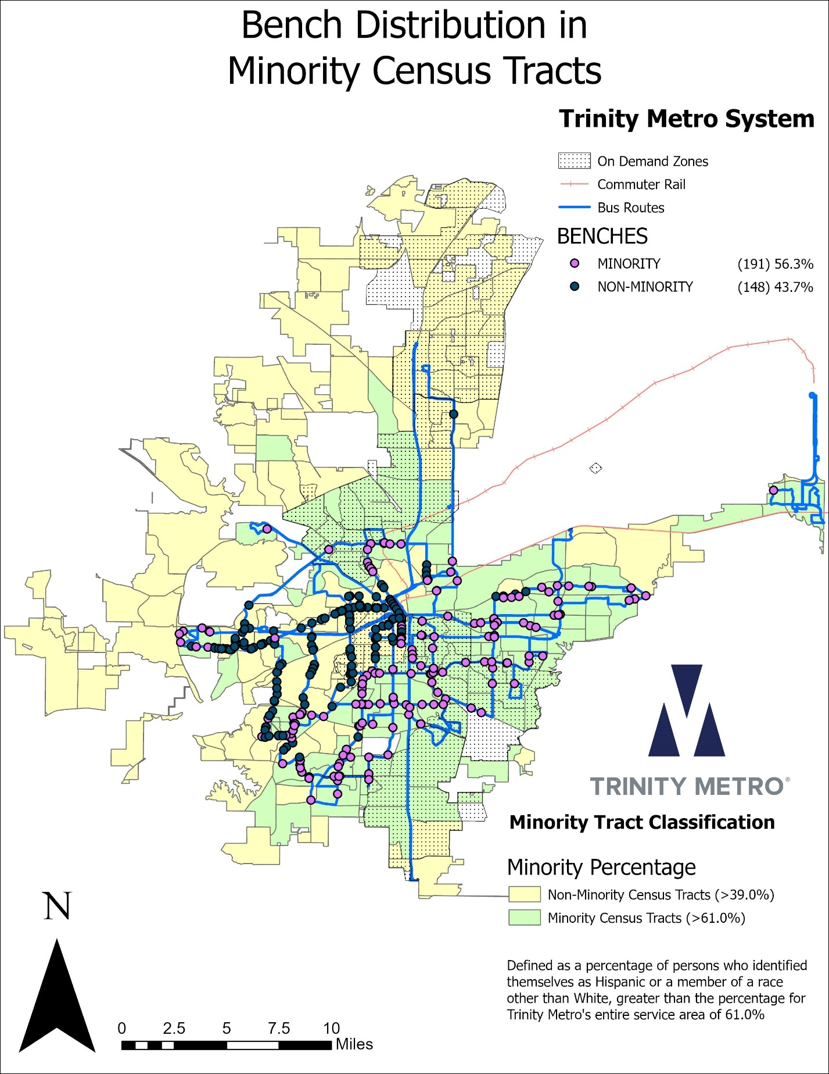
MAP: Existing Benches with Income Census Tracts Overlay
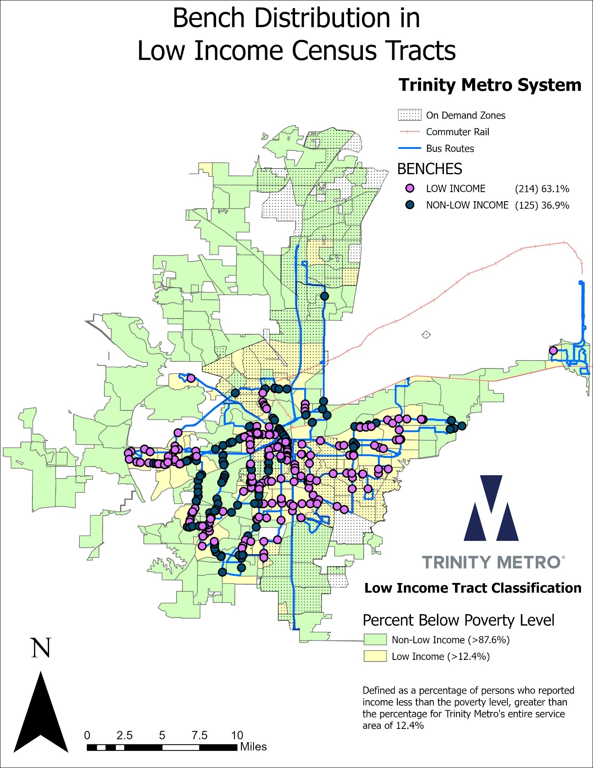
MAP: Existing Shelters Minority Census Tracts Overlay
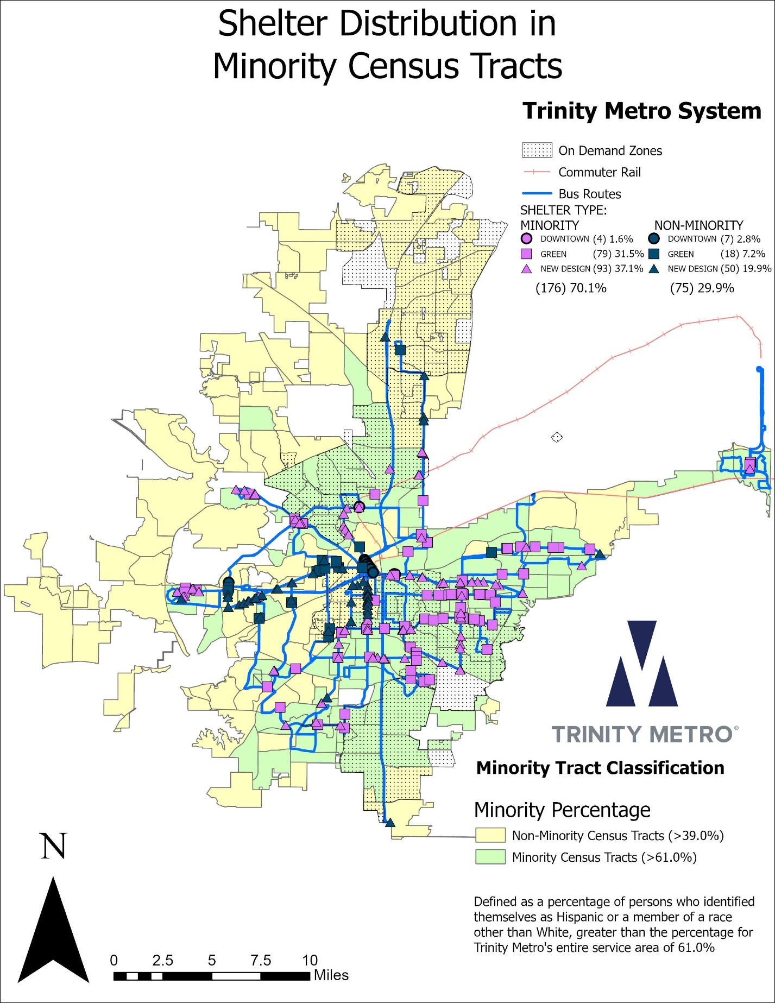
MAP: Existing Shelters with Income Census Tracts Overlay
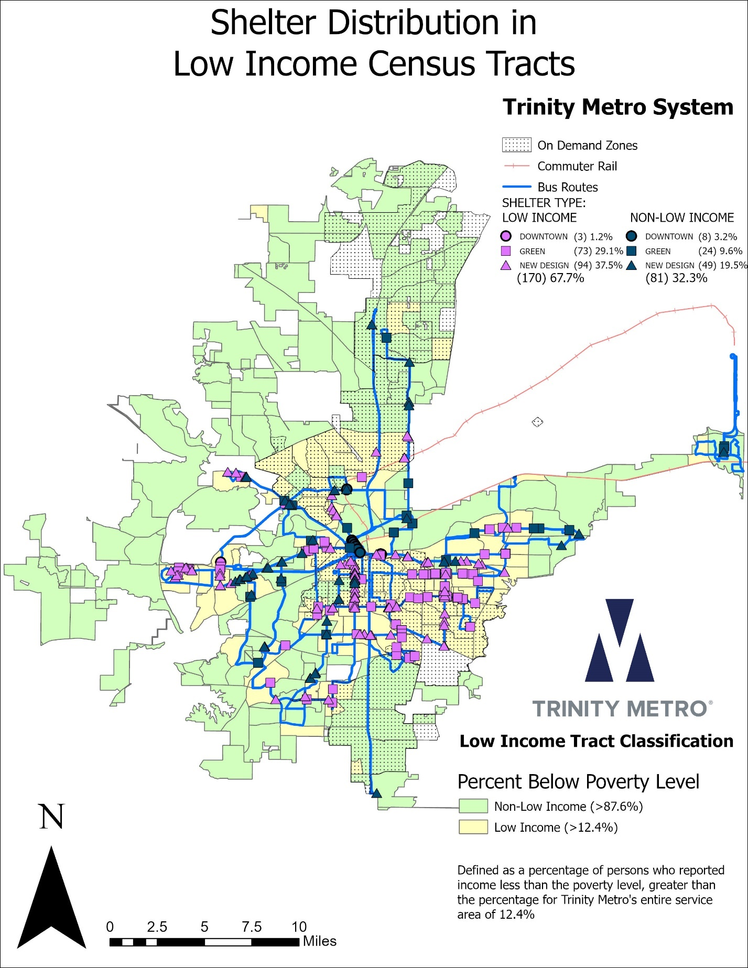
MAP: Existing Digital Signs with Minority Census Tracts Overlay
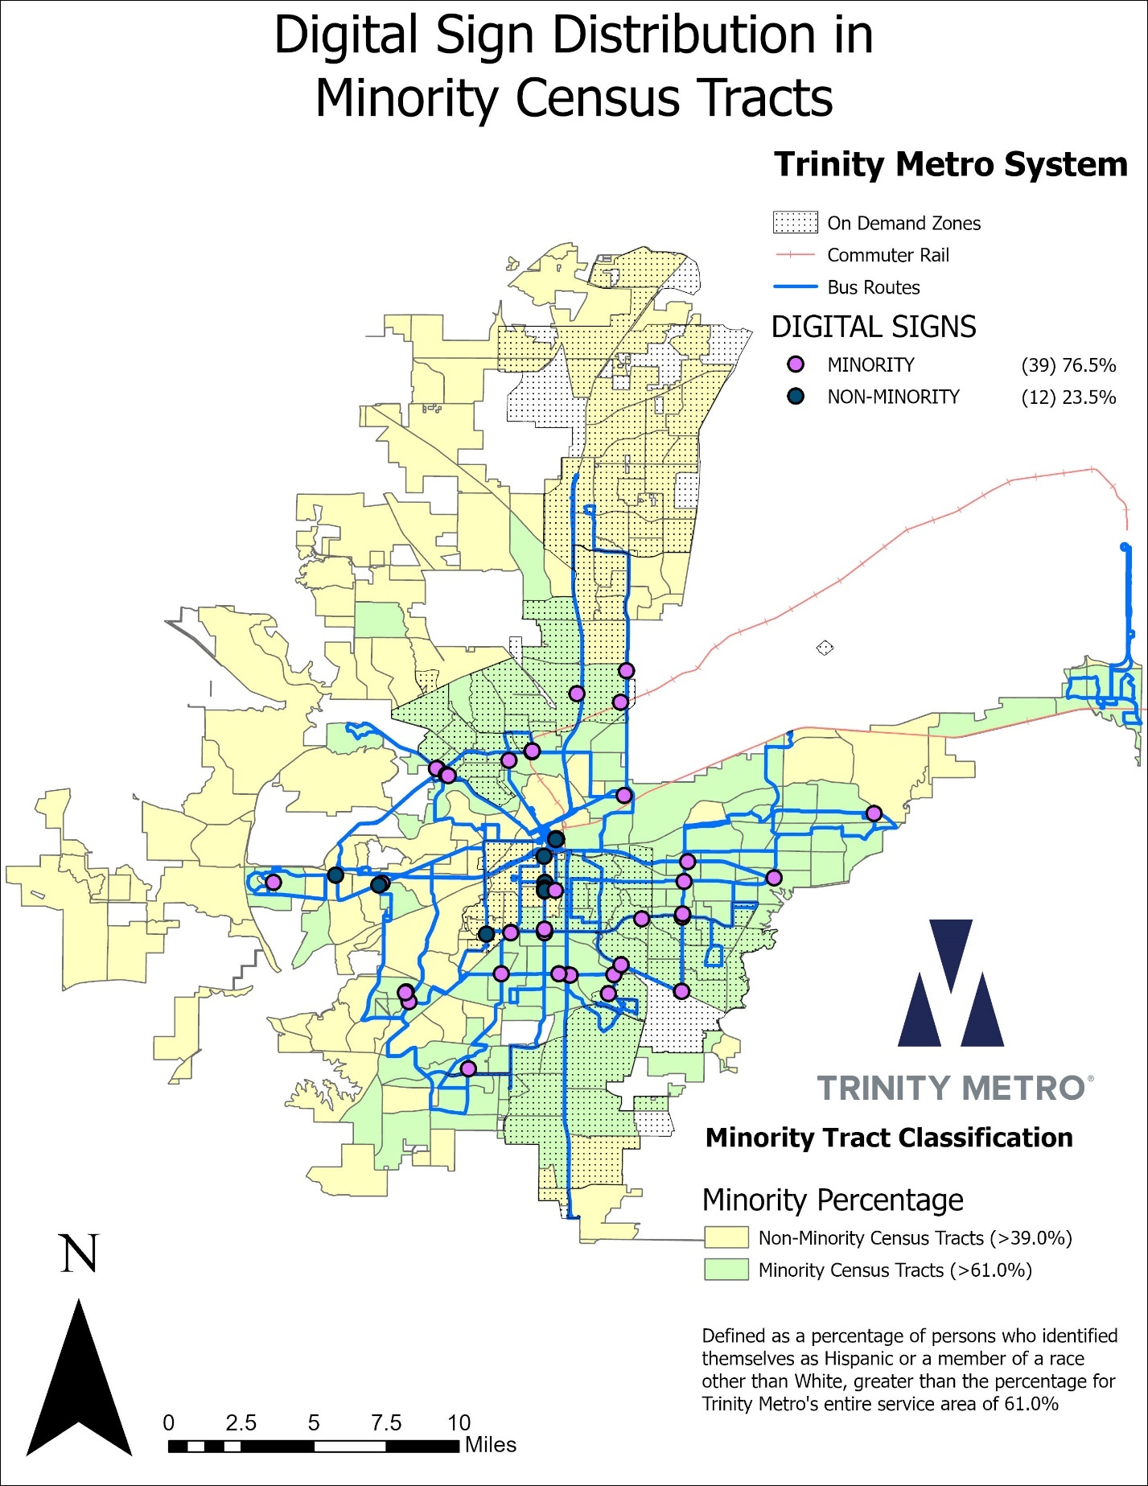
MAP: Existing Digital Signs with Income Census Tracts Overlay
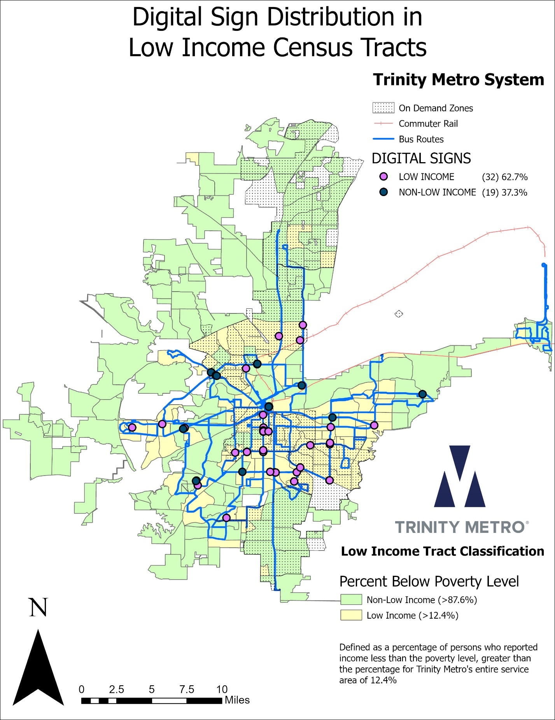
MAP: Existing Solar Lights with Minority Census Tracts Overlay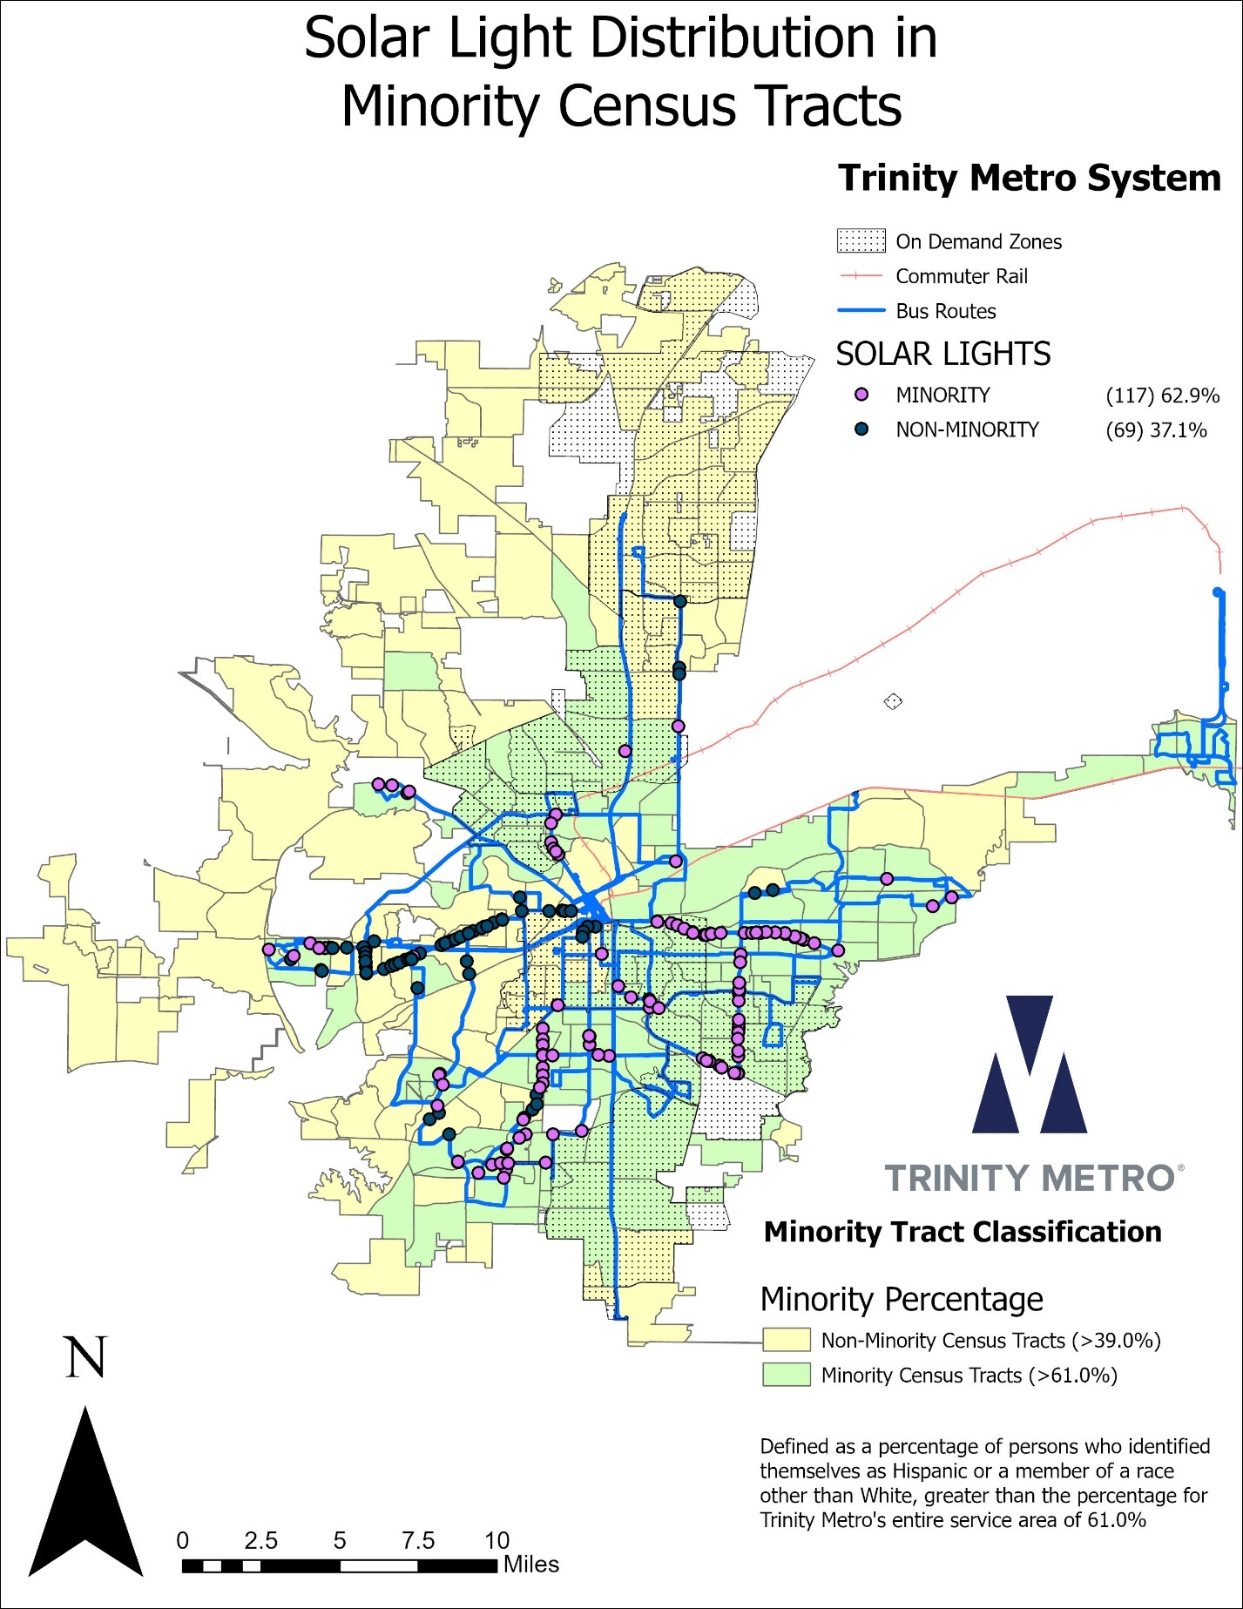
MAP: Existing Solar Lights with Income Census Tracts Overlay
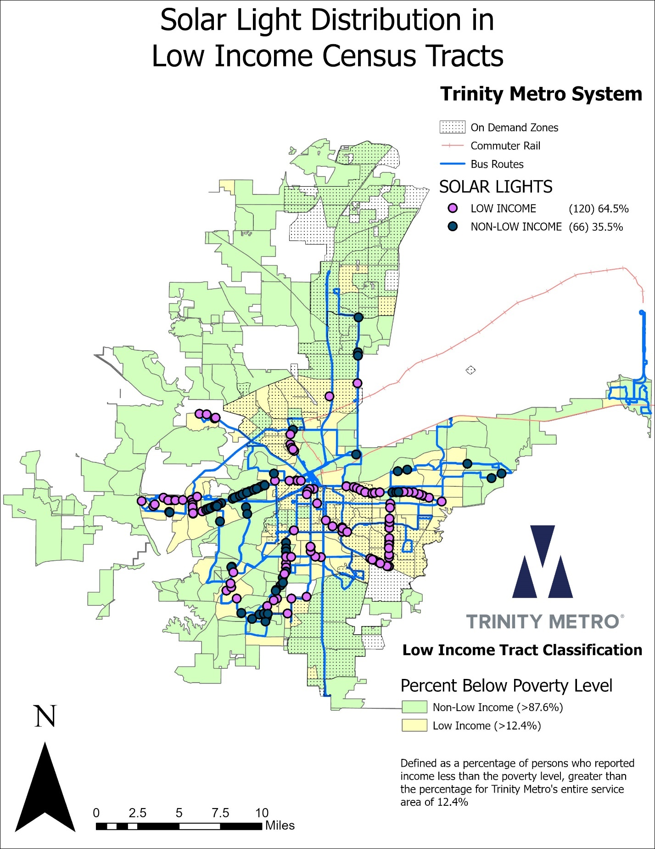

Transit Center Distribution Assessment
Trinity Metro has constructed six Transfer centers within its member cities. The below chart lists each Center and identifies the Minority/Non-Minority, Low-Income/Non-Low-Income status of the census tract it is located within.
Transit Center Identification and Distribution
Facility | Minority Status of Area Census Tract | Income Status of Area Census Tract
Dr. Dennis Dunkins Transfer Center (formerly named East Transfer Center) | Minority | Non-Low-Income
Fort Worth Central Station (formerly named Intermodal Transportation Center) | Non-Minority | Non-Low-Income
North Side Transfer Center | Minority | Non-Low-Income
La Gran Plaza Transfer Center | Minority | Low-Income
Vickery Blvd. Transfer Center (T&P) | Non-Minority | Low-Income
Sierra Vista Transfer center | Minority | Low-Income

Four of six bus transfer centers are within minority areas and three of six are in low-income areas. It should be noted that Dr. Dennis Dunkins Transfer Center is in a non-low-income Census Tract (low-income when constructed) that is surrounded on all sides by low-income tracts and serves the low-income community in the southeast quadrant of Fort Worth. North Side Transfer Center is similarly on the border of low-income tracts in a historically low-income neighborhood.

Park & Ride Facility Standards
Trinity Metro owned park & ride facilities are treated with passenger amenities including canopies/shelters, benches/seating, lighting, trash receptacles, security cameras, attractive landscaping, route maps and schedule information. New park & ride facilities are rarely added but must go through EJ assessment, the new services be evaluated for Title VI equity and be equally equipped as existing facilities.

Park & Ride Facility Assessment
Both Park & Ride facilities are in non-low-income and non-minority Census Tracts. Locations were chosen primarily for their accessibility from the freeways and ability to service congestion-reducing routes with air quality benefits which is also part of the public transit mission. There were no new Park & Ride Facilities added during the assessment period.

Commuter Rail Facility Standards
All TRE stations have low-level boarding with high-blocks for mobility-impaired passengers and TEXRail stations have level boarding. The TRE stations at a minimum can accommodate four passenger cars and TEXRail Stations can accommodate the current Diesel Multiple Units (DMUs). Other key features of stations are:
- Platform with textured warning strip at edge;
- High-block platform with ramps to permit level boarding by wheelchair users and mobility-impaired passengers
- Ticket vending machines
- Canopies;
- Benches/Seating
- Lighting
- Trash receptacles
- Security cameras
- Route Maps and Schedule Information
- Pedestrian track crosswalks as appropriate
- Landscaping features such as planters and trees
- Shared Ride Pick-up and Drop-off facilities
- Park-and-ride facilities at all stations excluding Fort Worth Central Station, Medical Market and DFW Terminal B stations which are “destination” locations.
New stations are rarely added but must be equally equipped as existing stations.

Commuter Rail Station Spacing Standards
Station spacing is important for efficient running time of the commuter rail which, as opposed to light rail technology, has longer acceleration and deceleration times. The average spacing along the TRE Commuter Rail line is 3.6 miles apart.
Initial placement of the stations was determined based upon ridership projections, site development suitability, potential for Transit Oriented Development, transit access, environmental impact, host railroad agreements and municipal financial participation. Many technical factors regarding rail operations dictate station spacing and thus having evenly spaced or ideal locations may not be possible. If new stations are proposed, technical feasibility analysis will be the primary deciding factor.
The following are the existing spacing between the stations:
Segment | Stations | Distance between Stations (in miles)
1 | T&P Building to Fort Worth Central Station | 0.75
2 | Fort Worth Central Station to Trinity Lakes | 7.86
3 | Trinity Lakes to Hurst-Bell | 3.22
4 | Hurst-Bell to Centerport | 6.16
5 | Centerport to West Irving | 2.56
6 | West Irving to South Irving | 3.5
7 | South Irving to Medical/Market Center | 6.3
8 | Medical/Market Center to Victory | 0.94
9 | Victory to Union Station | 1.35
 | Average Distance between Stations | 3.62
 | Total Distance on Tracks | 32.62
TEXRail Station spacing is largely determined by municipal financial participation as unlike TRE, a large proportion is outside the Trinity Metro service area. While all TRE stations were constructed within member cities, TEXRail participation is governed by long-term service contracts with Cities along the corridor. Grapevine and North Richland Hills currently participate.
Segment | Stations | Distance between Stations (in miles)
1 | T&P Building to Fort Worth Central Station | 0.75
2 | Fort Worth Central Station to North Side Station | 3.41
3 | North Side Station to Mercantile Center | 3.39
4 | Mercantile Center to Iron Horse Station | 3.12
5 | Iron Horse Station to Smithfield Station | 2.65
6 | Smithfield Station to Grapevine Main St | 9.28
7 | Grapevine Main St to DFW North Station | 1.43
8 | DFW North Station to Terminal B | 2.14
 | Average Distance between Stations | 3.27
 | Total Distance on Tracks | 26.18

Commuter Rail Facility Assessment
Five of the TEXRail Stations are within suburban cities that participate in its funding. There were no new stations added to TEXRail. The only new station added during the assessment period was Trinity Lakes Station on the TRE, located in a low-income but non-minority Census tract. It is well equipped as described in the Standards section above with ample parking and is connected to the historically disadvantaged communities of East and Southeast Fort Worth via Route 55. Station spacing changed by only a mile, however, moving closer to residential communities in east Fort Worth and providing a greenfield opportunity to develop a true Transit Oriented Development adjacent to the new Trinity Lakes Station.

Minority and Low-Income Assessment – Additional Evaluations

Customer Satisfaction
During the Fall of 2024, Trinity Metro engaged ETC Institute, a prominent national transit surveying firm, to conduct a Customer Satisfaction and Marketing Survey. The Passengers were approached onboard transit vehicles and asked to answer a series of questions. Target quantities were developed for each mode and route type while random number generation in the tablet software identified which passengers to be selected, thus ensuring that the results would be statistically significant and non-biased. Below shows the balance of survey respondents by both race and ethnicity combined. The majority, 1,512 of the 2,752 customers surveyed indicated minority status while 931 were non-minority and 309 did not disclose.

While the majority of passengers were not low income, the low income customers did make up the largest group with 878 out of 2,752 customers indicating an annual income of less than $20,000. It should be noted that 572 respondents refused to disclose their income, which the pie chart below does not account for.

It should be noted that that is difficult to get accurate income data in an intercept survey. People rarely know or remember their total household income from the previous year. Many share an apartment, live with family, occasionally in multi-generational households, or change living situations during the year. Many are not aware of how much their spouses, parents, siblings or roommates made nor how much total income their household(s) generated. Even those who live alone will have multiple sources of income, both taxable and non-taxable and change jobs during the year. While it might seem natural to assume that low income should mean a simpler tax return, its often quite complex and such complexity motivates many low income individuals to seek help preparing their returns.
Unlike when filling out a Census form or housing voucher application at home where one could refer to their previous year’s tax return, when encountering a surveyor on a bus at random, many people are unlikely to remember very precisely the one critical line which would define their poverty status. For Title VI statistical purposes, we’ve chosen to use rather wide income brackets and define any adult that lists under $20,000 as low-income regardless of their household size. For the average household size of three persons in 2022 (at the time of the survey), the Census Bureau shows $23,280 as the poverty threshold for the United States. Housing and Urban Development calculates $24,400 for the Fort Worth Arlington PMSA, which is slightly greater than the Health and Human Services Department’s reporting of $23,030 for the contiguous United States. Our survey threshold of $20,000 is very close to the poverty thresholds for a family of three indicated by the three prominent federal agencies and about as accurate as anyone is likely to be able to answer when put on the spot.

Several service qualities were queried in the survey with passengers asked to score each attribute with a 1 through 5 to indicate:
- 1 – Very Dissatisfied
- 2 – Dissatisfied
- 3 – Neutral
- 4 – Satisfied
- 5 – Very Satisfied
In 5 of the 7 categories, the percentage of respondents that were “very satisfied” increased from 3 years prior., Customers were generally happy with the service provided on all modes of travel with less than 10% of respondents scoring a 1 or 2 on each attribute.
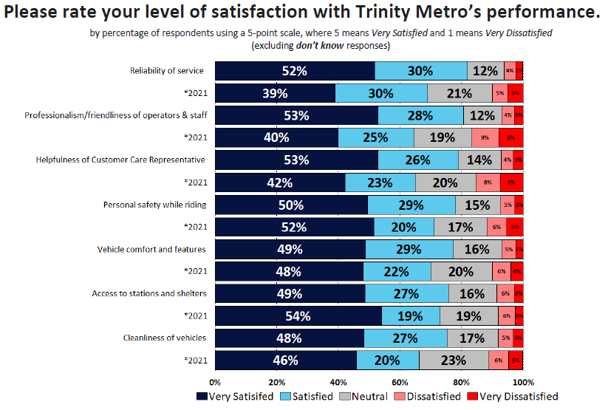

When parsing out satisfaction by minority responses vs non-minority responses, there were only small differences in the average level of satisfaction.
Service Attribute | Non-Minority | Minority
Q3[01] [Reliability of service] | 4.31 | 4.28
Q3[02] [Vehicles running on schedule] | 4.18 | 4.11
Q3[03] [Frequency of bus/train] | 4.14 | 4.22
Q3[04] [Condition of stations/stops] | 4.13 | 4.20
Q3[05] [Access to stations and shelters] | 4.28 | 4.28
Q3[06] [Vehicle comfort and features] | 4.27 | 4.27
Q3[07] [Cleanliness of vehicles] | 4.27 | 4.18
Q3[08] [Personal safety while riding] | 4.25 | 4.25
Q3[09] [Personal safety while waiting at stations/stops] | 4.01 | 4.10
Q3[10] [Onboard security] | 4.09 | 4.06
Q3[11] [Amenities at transit centers] | 3.98 | 4.07
Q3[12] [Professionalism/friendliness of operators and staff] | 4.34 | 4.30
Q3[13] [Helpfulness of Customer Care Representative] | 4.36 | 4.31

However, when comparing low-income responses to non-low income responses, the differences were more drastic. On average, ratings from low income respondents were 0.15 points lower per attribute than that of their non-low income counterparts. This raises cause for concern.
Service Attribute | Non-Low Income | Low Income
Q3[01] [Reliability of service] | 4.38 | 4.21
Q3[02] [Vehicles running on schedule] | 4.22 | 4.01
Q3[03] [Frequency of bus/train] | 4.21 | 4.13
Q3[04] [Condition of stations/stops] | 4.19 | 4.14
Q3[05] [Access to stations and shelters] | 4.34 | 4.15
Q3[06] [Vehicle comfort and features] | 4.33 | 4.14
Q3[07] [Cleanliness of vehicles] | 4.29 | 4.11
Q3[08] [Personal safety while riding] | 4.30 | 4.19
Q3[09] [Personal safety while waiting at stations/stops] | 4.10 | 3.98
Q3[10] [Onboard security] | 4.15 | 3.97
Q3[11] [Amenities at transit centers] | 4.06 | 3.99
Q3[12] [Professionalism/friendliness of operators and staff] | 4.38 | 4.21
Q3[13] [Helpfulness of Customer Care Representative] | 4.43 | 4.17

Staff analyzed the data further in attempt to locate the source of these slight differences is satisfaction levels. They looked at additional collected demographics to determine if there might be discrepancies driven by such things as age of the respondent as well as factoring in the relative importance of each service attribute. More critically, they looked at the responses by mode and by route to determine if they could actually pinpoint a problem on a specific service or geographic area.
The findings indicated low-income respondents were simply slightly more likely to choose one point lower on the five point scale with all else being equal. Low Income average overall ratings were on average 0.67 points lower non-low income average scores when parsed by bus route. The most drastic difference in ratings were Helpfulness of a Customer Care Representative, Access to Stations and Shelters, and Vehicle Comfort and Features. The three lowest rated service attributes by low-income respondents were Amenities at Transit Centers, Personal Safety while waiting at stops, and Onboard Security.
Among the five lowest rated routes by low-income riders, the lowest rated attributes tended to be Onboard Security and Personal Safety while waiting at stops. Since those were also among the lowest rated on all routes, this suggests that many of our low-income riders do not feel especially safe at our bus stops. Since this survey was conducted, many solar lights have been implemented throughout our system, especially in low-income census tracts, which could help the issues.
Even though there were routes that were rated lower than others, the general conclusion was that there was not a particular route or mode of service that could be identified as being suspect. The difference was likely due to the life circumstances of low-income passengers. It is well documented that these groups face challenges that less often affect non-low-income. Some of these challengers are geographical constraints such as where their job is in relation to where they live. Likely low-income passengers are more greatly impacted by the same operational aspects of the same mode, route or schedule thus resulting in the differences seen in this most recent Customer Satisfaction Survey.

Analysis of Public Participation 2023 – 2026
While not all public meetings and outreach involve imminent proposed major service changes or fares, a substantial proportion of attendees come to engage with agency staff about their own local routes and issues rather than the topic at hand, thus all 15 public meetings during the period are listed. Public Participation primarily centered around major and minor service changes during the previous three-year period, as well as proposed changes to the service standards and the Title VI program. Additionally, six Open Houses were held, focusing on customer and community engagement. There were four qualifying major service changes, and ten minor service changes from September of 2023 through February of 2026.

Public Meetings (Service Changes)
June 6, 2023
A public meeting was held at the Catholic Charities from 6-7 PM to discuss increasing Route 25’s weekday frequency from 30 to 15 minutes, as well as small routing changes to Routes 4 and 33.
March 28, April 3, and April 4, 2024
Four public meetings were held to discuss the discontinuation of Routes 28 and 45, the implementation of the North Side On-Demand Zone, Fare Changes, and the rebranding of Route 15 as the Orange Line. The first meeting was held on March 28th from 6-7 PM at the Courtyard by Marriott next to the Stockyards. The second was held on April 3rd from 6-7 PM at the William McDonald YMCA. The last two were held at Fort Worth Central Station on April 4th, the first of which taking place from 12-1 PM, and the second taking place from 6-7 PM. Overall, there were 40 comments from the public.
September 17, 2024 (TEXRail)
Two presentations were conducted on-board TEXRail trips explaining the proposed schedule changes. Additionally, a public meeting was conducted at Fort Worth Central Station later that day at 5 PM.
February 3, 2025
A public meeting was held at Fort Worth Central Station from 6-7 PM to discuss the rebranding of Molly the Trolley to the Blue Line, as well as schedule changes to Route 11, 16, and 55.
July 14, 24, and 25, 2025
Three public meetings were held to discuss changes to routes 1, 4, 5, 6, 12, 16, 21, 22, 24, 25, 29, 33, 46, 51, 52, 53, 54, 55, 61X, and 91. The first meeting was held at Diamond Hill Branch of the Fort Worth Public Library on July 14th, while the last two were held at Fort Worth Central Station on July 24th. The first of the last two was held from 12-1 PM, while the second was held from 6-7 PM. There were 14 comments at the first meeting on the 24th, and zero comments at the other two meetings.
October 27, 2025
A public meeting was held at the Ella Mae Library from 6-7 PM to discuss the Route 4 Extension, as well as a slight schedule change to Route 2.

Open Houses
June 15, 20, 22, 25, 26, 27, 2024
Six Open Houses took place in late June 2024. These featured interactive stations with stickers and post-it notes. Member of the community could talk to Trinity Metro employees directly, discussing what type of improvements they would like to see in the system. Overall, there were 55 comment cards received across all the events. Below are the dates, times, and locations of these Open Houses:
Saturday, June 15, 11:30 a.m.-1:30 p.m., Fort Worth T&P Station
Thursday, June 20, 6-7:30 p.m., Fire Station Community Center
Saturday, June 22, 11:30 a.m.-1:30 p.m., Eugene McCray Community Center
Tuesday, June 25, 6-7:30 p.m., R.D. Evans Community Center
Wednesday, June 26, 6-7:30 p.m., Riverside Community Center
Thursday, June 27, 6-7:30 p.m., Northside Community Center

Title VI Program
Thursday, December 18, 2025
12 PM, Trinity Metro Board Room, 801 Grove Street (In-Person and Recorded)
6:00pm, Fort Worth Central Station, 1001 Jones Street (In-Person)

Summary of Major Service Changes
During the previous Title VI program period we had a total of twelve service changes of which four included major route and schedule changes and eleven included minor route and schedule changes.
Trinity Metro defines a major service change as:
- An increase or decrease of 25% or more of the number of transit route miles of a transit route
- An increase or decrease of 25% or more of the number of transit revenue vehicle miles of a transit route, computed daily, for the day of the week for which the change is made
- The establishment of a new transit route
For each major service change in the preceding three-year period, a Title VI Analysis was completed using Remix software and no disparate impact nor disproportionate burdens were found.

September 17, 2023
Route 25’s weekday frequency was increased from 30 minutes to 15 minutes from 7 AM-7 PM. This route was identified as part of the "A Better Connection" system redesign study (2019-2021) as warranting an increase in frequency, but was not implemented at that time due to budget constraints. It was the consultant's recommendation to implement as soon as budget allowed.

September 15, 2024
Route 5’s weekday frequency was increased from 30 minutes to 15 minutes, and weekend frequency from 60 minutes to 30 minutes. Route 5 had often been ranked 5th in ridership, ranking above and routes with 15-minute frequencies. It was identified as part of the "A Better Connection" System redesign study (2019-2021) as warranting an increase in frequency but was not implemented at the time due to budget constraints. It was the consultant's recommendation to implement an increase in frequency as soon as the budget allowed.
Route 23, which operated between Trinity Lakes TRE Station and TCC Northeast Campus, was discontinued. It was replaced with a non-dedicated, on-demand service. The vehicles provide service between Trinity Lakes Station and TCC NE Campus only. Implementation of an on-demand service through a non-dedicated transit network company (TNC) to provide transportation for TCC NE Campus is more cost-effective than having a fixed route bus and operator all day due to vary low ridership volume. By doing so, those resources can be dedicated to the improvement of other fixed-route services.
Route 28, which served Southeast Fort Worth, was discontinued. Ridership remained stagnant following the system redesign and pandemic recovery at around 50 boardings per day, and was one of the lowest performing routes. The route was also entirely within the Southeast On-Demand Zone, which has the same span of service.
Route 45, which served TCC Northwest campus and the North Side area of Fort Worth, was discontinued. Ridership remained stagnant following the system redesign and pandemic recovery at around 50 boardings per day, and is currently one of the lowest performing routes. Public feedback listed a wide variety of desired destinations that would be impossible to serve with a single bus route. It was replaced with the new North Side On-Demand Zone, which has the flexibility to serve all of the desired destinations.
The DASH, which connected the Cultural District to Downtown, was discontinued. The Dash service began shortly before the COVID-19 pandemic as part of a Blue Zones inspired pilot project to promote healthy lifestyles, attract new riders to transit from among Downtown and West 7th Street area residents, reduce traffic confection, and improve air quality and relieve parking constraints. Ridership growth was quickly interrupted by the pandemic and never recovered even to pre-pandemic levels, prompting funding partners to discontinue support. The DASH electric vehicles were repurposed for the Blue Line.
Route 66X, an express route that operated between Southwest Fort Worth and Downtown during peak hours only, was discontinued. It had the lowest number of riders compared to other express routes. In the Southwest Fort Worth area, there are three other routes (6, 52, 72) that serve most of the area, and have stops that overlap with Route 66X. This route uses two buses and two operators during the peak. These resources can be reallocated to improvements on Route 5 and other fixed-route services.

June 8, 2025
Molly the Trolley, a Downtown Circulator, was rebrand as the Blue Line. The service hours were adjusted from 10 AM – 10 PM, to 7 AM – 7 PM, and increased frequency from 10 minutes to 7 minutes. With earlier service hours and increased frequency, riders can conveniently travel to and from local hotels for events at the convention center, and the improvement makes it easier to explore downtown and connect with other Trinity Metro transportation options.

January 18, 2026
Route 4’s frequency will be adjusted from 15 minutes to 30 minutes, as the route will extend further west on Rosedale and north on Montgomery to the Cultural District. This extension also includes a current detour along Camp Bowie, between Montgomery St. and University Dr. Adjusting the route frequency improves efficiency and allows savings for extending the route west along Rosedale Ave. Further extending the route north on Montgomery St. to serve Dickies Arena provides convenient transportation for event attendees, and includes stops at nearby museums to enhance cultural access for residents and visitors. This improvement promotes better connectivity to support local businesses and attractions in these areas.

Summary of Minor Service Changes

May 21, 2023
The schedule on West Loop Route 30 was adjusted to eliminate the U-turn on Statler Blvd. This change eliminated a westbound stop at Statler Blvd and Stapleton Ln, which had zero ridership. The times for existing time points did not change.

July 3, 2023
The routing directions on Route 30 Amon Carter and East Loops were altered to eliminate the need for making U-turns on Statler Blvd. The times at all the time-points will not change. Due to the center divider on Statler Blvd, this change will prevent operators heading northbound, from making a U-turn when entering or exiting CentrePort Station.

September 17, 2023
The bus layover location for Route 4 at Cook Children's Medical Center was changed to West Rosedale St and 8th Ave, in order to address the Medical Center administrations’ safety concern.
Route 33 now serves the VA Clinic on westbound excursions only in order to maintain on-time performance. The schedule was adjusted for each time point.
The timepoint on Northside Station for Routes 54 and 91 was adjusted by one minute to allow the train to meet with the bus.

January 15, 2024
Route 45 was slightly re-routed within TCC Northwest Campus due to a new design of the parking lot. As a result, a new shelter for the new bus stop was constructed.

February 19, 2024
Route 55’s schedule was adjusted due to the closure of TRE Richland Hills Station and re-route to the new Trinity Lakes Station. The City of Richland Hills voted to withdraw from membership in Trinity Metro, and as a result, the Richland Hills Station was replaced by a new station within Fort Worth City Limits, approximately nine-tenths of a mile to the east along the rail line. Service has moved to the new Trinity Lakes Station. Additionally, the time-points at Bridgewood & Boca Raton were moved to Bridgewood & Bridge. The time-points at Bridgewood and Boca Raton were established to facilitate transfers between Routes 55 and 21; however, since Route 21 now travels down Bridge St., the new time points create closer transfer connections.

March 17, 2024
Route 15’s schedule was adjusted for Friday and Saturday evenings to increase the frequency from 30 minutes to 15 minutes, and extend service hours. This meets the needs of riders attending events in and around the Fort Worth Stockyards.

September 15, 2024
Route 15 was re-branded as the Orange Line, altering the pattern through downtown and extending service to operate every 15 minutes from 5 AM – 1 AM, 7 days a week. This change helps promote tourism in the Stackyards area, and attract visitors to Fort Worth. Altering the route to better serve hotels and expanding the evening frequency will encourage tourists to use transit to and from the airport, conventions and traveling between downtown and the Stackyards.
Molly the Trolley’s route was adjusted to add a stop on Lancaster Ave, in front of T&P Station. The $1.75 Million Lancaster T&P Passage Project, funded by the City of Fort Worth's Tax Increment Reinvestment Zone District Eight, created a more formal arrival and departure experience to guide TEXRail and TRE riders between the T&P Terminal Platform and Downtown Fort Worth using signage, graphics, historic exhibits, landscaping, and light.
Route 30 West Loop’s timepoint at Skyview 5 was adjusted time by two minutes, allowing for an earlier arrival at CentrePort Station for riders transferring to TRE. The East Loop now bypass Grand River Rd & High River Rd on the 3:20 pm trip only.
The Southside On-Demand Zone was expanded to include the Sycamore Heights neighborhood. Public feedback noted that because there is no north-south route between Riverside Drive and Oakland Blvd, requiring multiple transfers to reach the nearest source of fresh groceries at the Walmart at Renaissance Square. The Southside On-Demand Zone serves most of the area and a small extension of the Sycamore Heights neighborhood provides that critical connection.

November 3, 2024
The TEXRail schedule was adjusted to maintain 30-minute frequency from 4 AM-7:30 PM, but a few early morning and late night trips were discontinued. Going eastbound, the first trip leaving Mercantile Center at 3:31 AM was discontinued, and the first trip leaving T&P Station now leaves from Mercantile instead at 4:01 AM. Two late morning trips that terminated at North Side Station were extended all the way to DFW, and two early afternoon trips that originated from Mercantile now originate from T&P, running all the way to DFW. Additionally, three new full-length mid-day trips were implemented. The last two eastbound full-length trips were discontinued.
Going Westbound, the first trip departing DFW at 4:40 AM will now originate from North Side, meaning the first trip out of DFW is now at 5:10 AM. Five new full-length mid-day trips were implemented. The last two westbound trips were discontinued, and the new latest trip now leaves DFW at 12:10 AM instead of 12:40 AM, and goes only to Mercantile instead of T&P.

April 13, 2025
Route 11’s pulse was changed from Mercantile Station to Fort Worth Central Station. The route now leaves Central Station at 15 and 45 minutes after the hour to enhance connectivity to other routes. As a result, Route 16’s schedule was changed, as it is interlined with Route 11. Route 55’s schedule was adjusted to increase travel time between specific timepoints to improve on-time performance.

June 8, 2025
The turn-by-turn directions for Routes 2 and 52 were updated as a result of long-term construction for a street improvement project along Camp Bowie. Additionally, the turn-by-turn directions for Routes 12, 91, and Orange Line were updated due to a railroad bridge repair project at NE 28th St and Decatur Ave. The updated route directions will allow more accurate tracking of information for National Transit Database (NTD) reporting AND more current itinerary planning in apps such as Google Maps and GoPass.

September 28, 2025
Due to low ridership and amid budgetary constraints, several trips across many routes were discontinued:
-Route 1: The last trip in each direction on weekdays and Saturdays
-Route 5: One morning northbound and one late night trip in each direction on weekdays
-Route 6: One morning northbound trip on weekdays
-Route 16: The last three Northbound weekday trips, the last two Northbound Saturday trips, the last Northbound Sunday trip, the last two Southbound weekday trips, and the last Saturday trip
-Route 24: The last weekday Westbound trip
-Route 25: The last weekday Westbound trip
-Route 29: The last trip in each direction
-Route 33: The last trip in each direction
-Route 46: The last Southbound trip, and the last two Northbound trips
-Route 51: The last trip in each direction
-Route 52: The last trip in each direction
-Route 53: The last two trips in each direction
-Route 54: The last trip in each direction
-Route 55: The last two Southbound trips, and last Northbound trip
-Route 61X: One Southbound weekday trip
-Route 91: The last trip in each direction
Because Route 11 is interlined with Route 16, the last three weekday Southbound trips, and last Southbound weekend trip were adjusted by three minutes.
Route 12 was discontinued in its entirety due to low ridership and underperforming trips. Most of the route was within the Mercantile and North Side On-Demand zones, and shares much of the same alignment as the Orange Line.
Routes 21 and 22 are now interlined at the Walmart at Eastchase & John T White, and their schedules were adjusted accordingly.

Summary of Fare Changes
On September 15, 2024, several fare reductions were made effective. As seen in the table below, Train and Express Bus fares were reduced from $2.50 to $2, and the reduced fares for those modes from $1.25 to $1. On-Demand (then called ZIPZONE) fares were reduced from $3 to $2, and the reduced fare from $3 to $1. Day Passes were reduced from $5 to $4, and reduced day passes from $2.50 to $2. The 7-day pass was reduced from $25 to $18, and the reduced weekly pass from $12.50 to $9. The 31-day pass and Annual Pass were discontinued.
 | Current Regular Fares | Proposed Regular Fares | Current Reduced Fares | Proposed Reduced Fares
Single Ride | $2.00 | $2.00 | $1.00 | $1.00
Express Bus/Train* | $2.50 | $2.00 | $1.25 | $1.00
On-Demand* | $3.00 | $2.00 | $3.00 | $1.00
Day Pass | $5.00 | $4.00 | $2.50 | $2.00
7-Day Pass | $25.00 | $18.00 | $12.50 | $9.00
31- Day Pass | $80.00 | Not Offered | $40.00 | Not Offered
Annual Pass | $800 | Not Offered | $400 | Not Offered
* All fares are the same regardless of mode. Express Bus, Train and ZIPZONE single rides become one fare.
Because both minority and low income passengers enjoy a savings, minorities moreso than average, and all groups were within 20%, there was no disparate impact nor disproportionate burden found.

Program Specific Requirements

Travel Patterns
The North Central Texas Council of Governments sponsors a regional onboard origin-destination survey. This survey includes all modes of three agencies, Trinity Metro, Dallas Area Rapid Transit (DART) and Denton County Transportation Authority (DCTA) to generate a travel model for the entire region. Surveys were conducted in September 2022, with the results becoming available in September 2023.
The data below is from the 2022 survey in which interviewed 4,914 passengers on all routes.
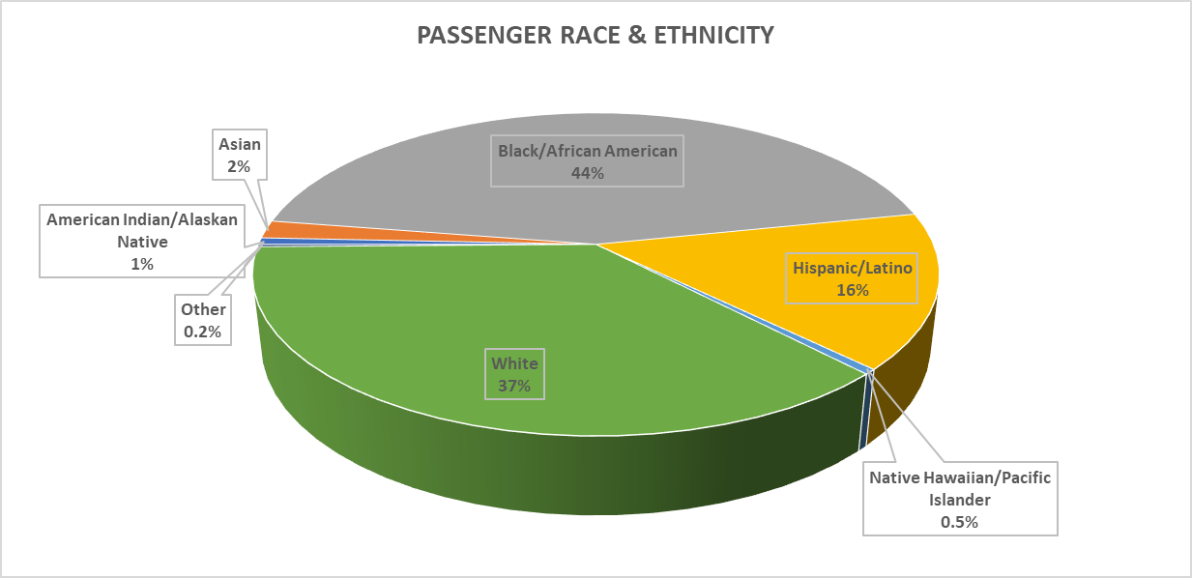
Minorities constituted 63% of the total ridership with Black/African American the largest group at 44%. Low-Income passengers accounted for 42.2% of the passengers surveyed.

Trip Purpose
 | Home-Based Work |  | Home-Based Social Recreation | Home-Based Shopping | Home-Based Personal Business | Home-Based School | Home-Based Other | Non-home-Based Other | Non-home-Based Work
Minority |  | 49.7% | 14.2% | 3.2% | 10.4% | 8.7% | 4.0% | 7.1% | 2.6%
Non-Minority | 49.5% |  | 14.2% | 3.2% | 10.5% | 8.8% | 3.9% | 7.2% | 2.6%
Low Income | 46.4% |  | 16.7% | 3.7% | 10.3% | 8.7% | 4.5% | 5.8% | 3.9%
Non-Low Income | 52.9% |  | 11.6% | 3.3% | 11.0% | 7.7% | 4.2% | 6.2% | 3.3%
Minority, non-minority, low income, and non-low income passengers tended to use transit for same types of trips in similar proportions. However, low income passengers had a higher share of social/recreation trips compared to the other groups. This could be because they are less likely to have access to a personal vehicle. The following maps show the volume of travel by destination traffic survey zone for minorities vs non-minorities and for low-income passengers vs non low-income passengers. Minority travel appears to be largely concentrated in the southeast portion of the city coincident with the largest concentration of Black/African American population according to the Census. Low income travel seems to be more widely spread. For both protected groups, the largest destination zones are well-covered by transit.
One of the most frequent requests received from passengers is for service outside of Trinity Metro’s political jurisdiction which is limited to the City of Fort Worth. Under current Texas law, most cities in Tarrant County do not have the taxing authority to raise funding to participate as a member of the public transit agency, however, Trinity Metro has adopted a policy to allow non-member cities to purchase limited transit service al-la-carte using whatever funding is available to them. The City of River Oaks has a Paratransit-only contract. The cities of Grapevine and North Richland Hills have contracts for TEXRail stations within their jurisdictions. Grapevine provides its own limited bus service, mostly tourist-oriented, but North Richland Hills does not have any route service. The City of Forest Hill has an On-Demand Contract. The City of Arlington provides mobility on demand service from the CentrePort TRE Station for a limited area within its city boundaries. Several cities provide limited transportation for the elderly and disabled, but only the cities listed above provide transit service to the general public. The North Central Texas Council of Governments recently completed a consultant study to determine the public transit needs of the region and are currently working on funding mechanisms and incentives to increase non-member cities participation in public transit.

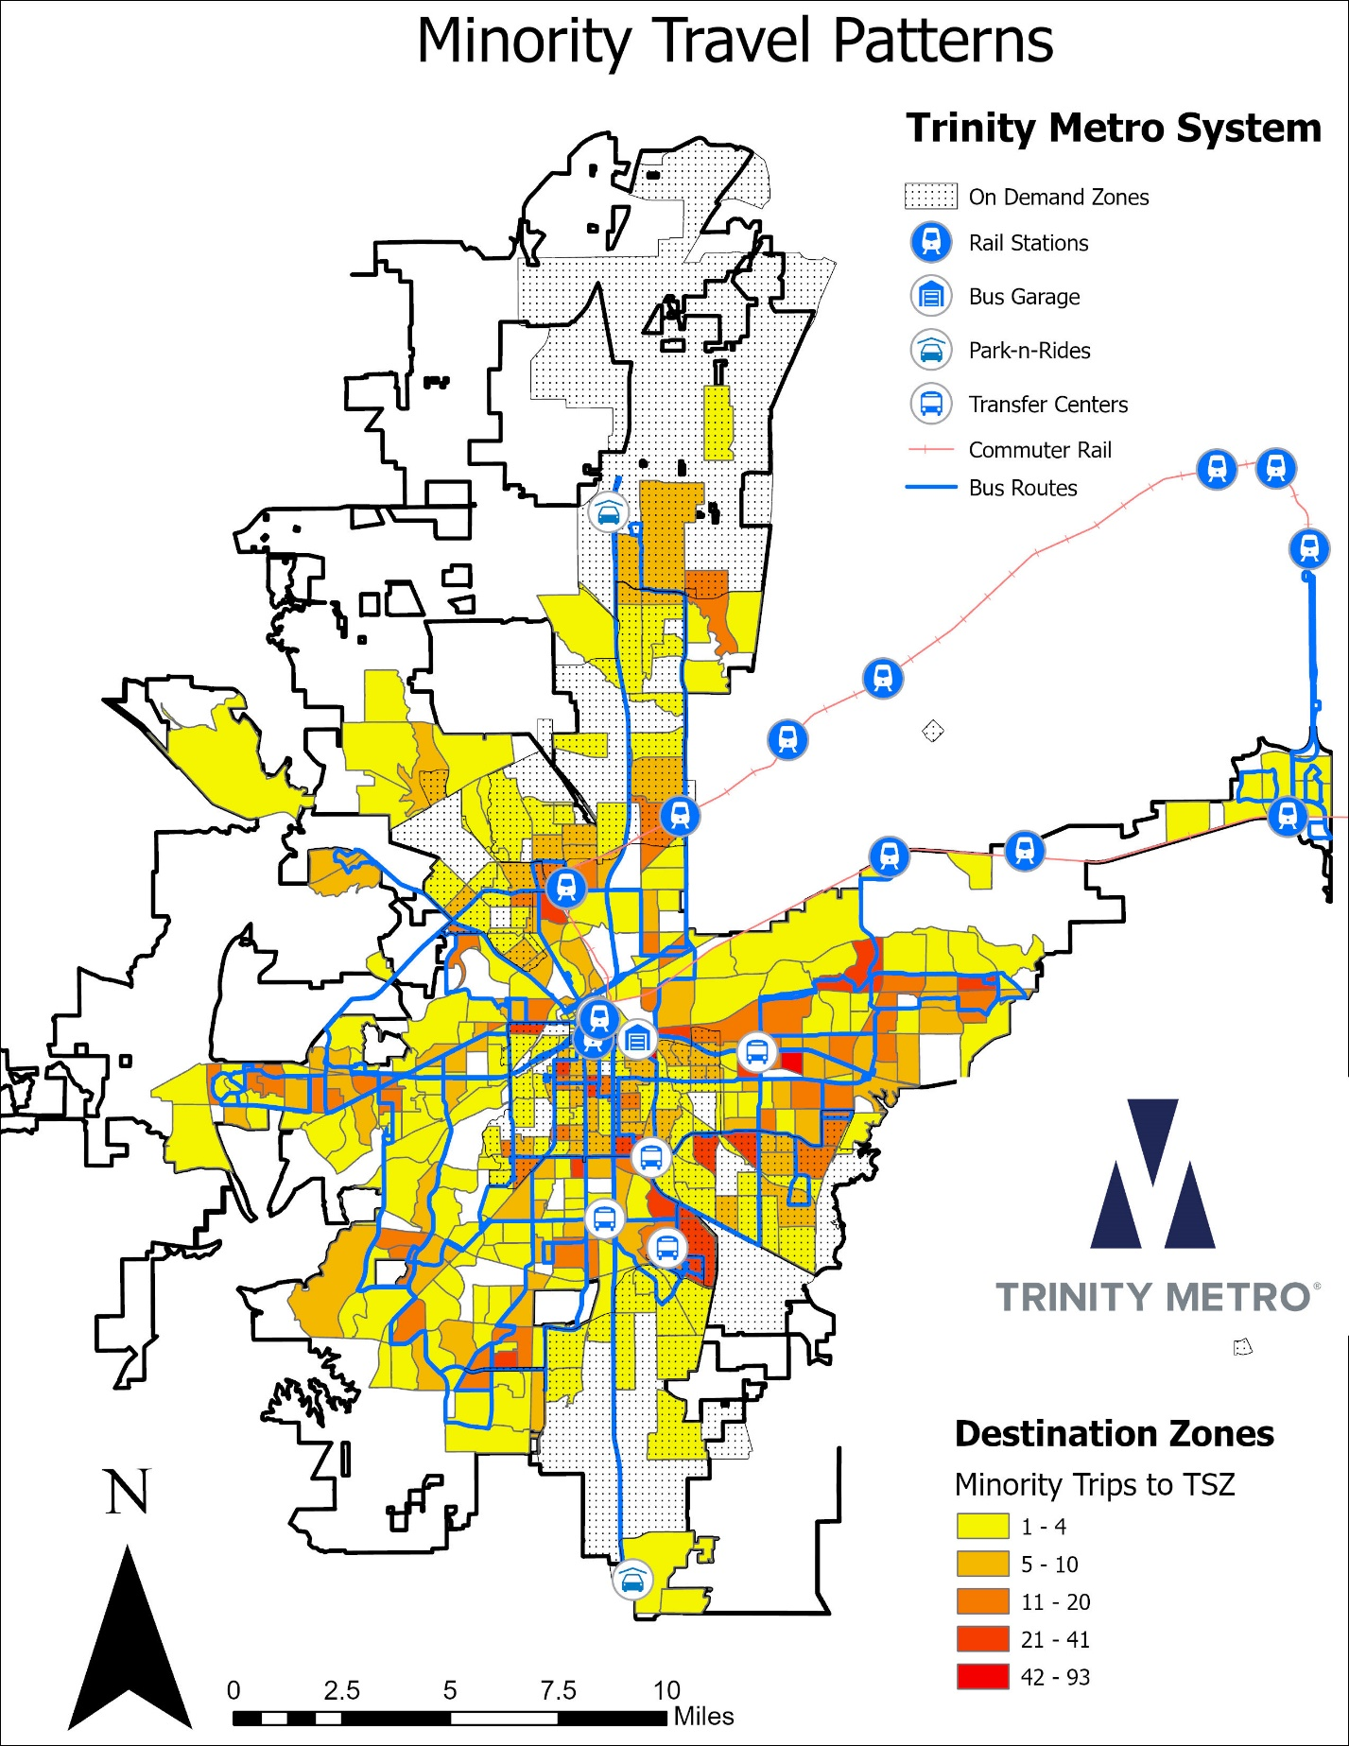

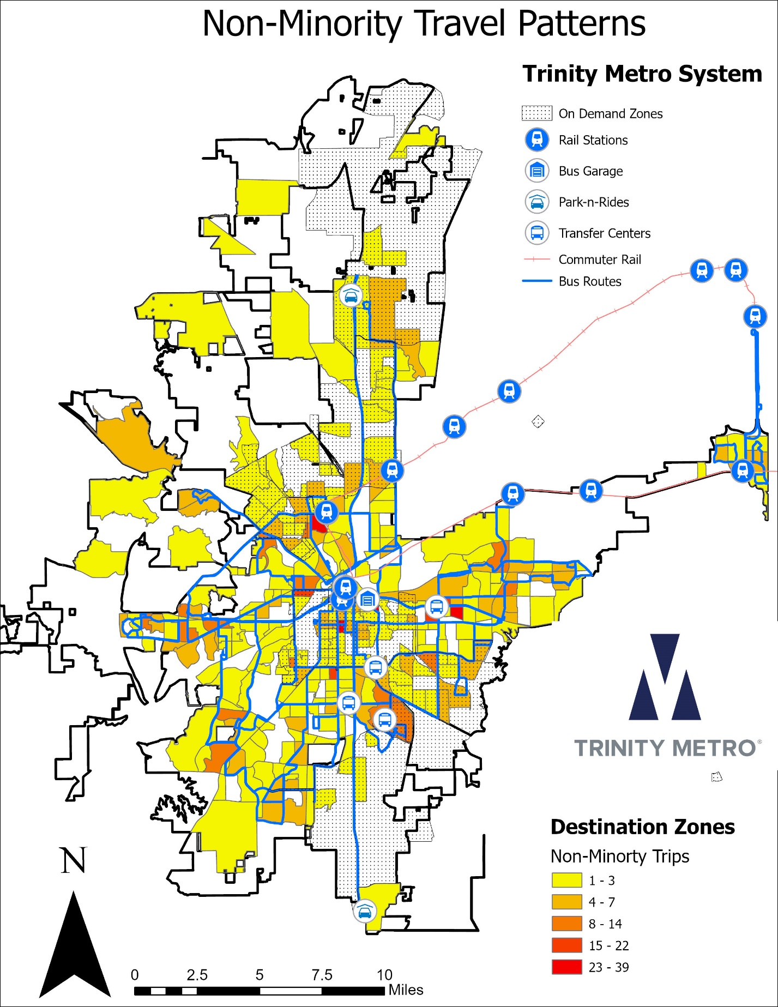
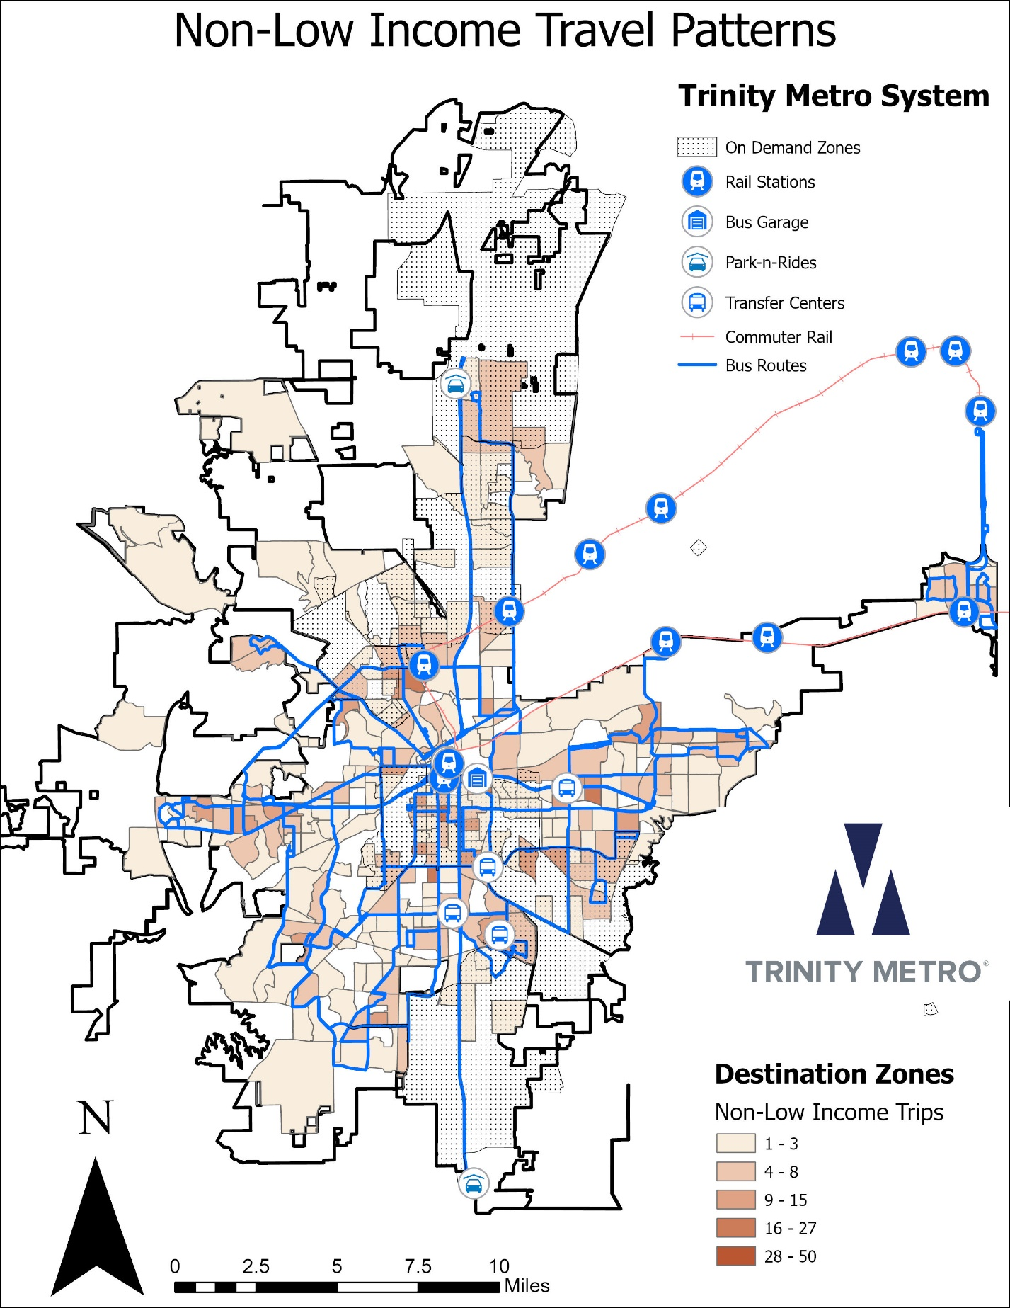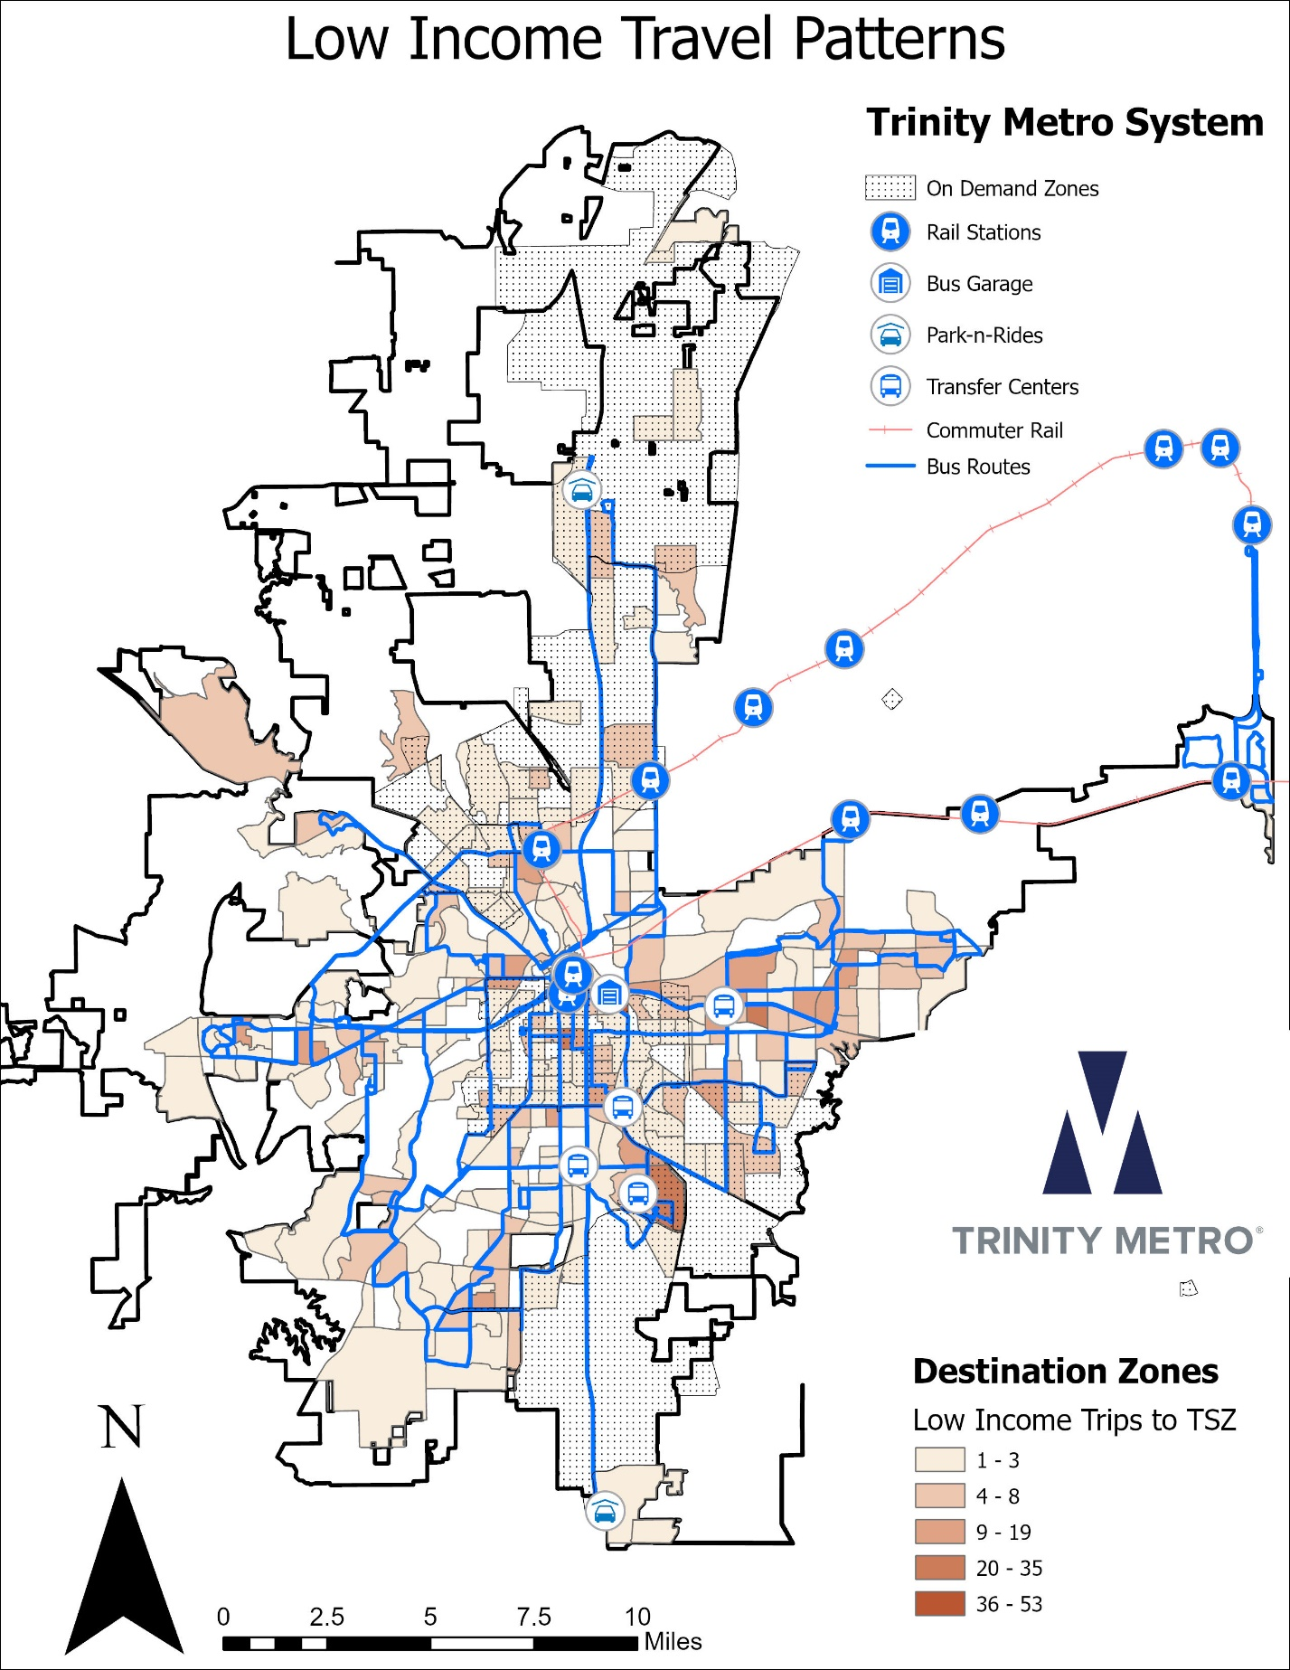

Sub-recipient Compliance
During this report period, Trinity Metro did not engage with any sub-recipients.

Equity Analysis for New Facilities
A Title VI Analysis was conducted for the discontinuation of the Richland Hills TRE Station, and the subsequent opening of the Trinity Lakes Station. No disparate impact was found for minority population within ¼ mile of the stations. No disproportionate burden was found for the low income population within ¼ mile of the stations.
Once the City of Richland Hills voted to opt out of Trinity Metro (then-Fort Worth Transit Authority) in 2016, the latter and TRE developed a plan to build a new station on the other side of I-820, which is in Fort Worth city limits. This new station, called Trinity Lakes, is approximately one mile east of the former Richland Hills station. Since the new station opened in 2024, trains and buses have ceased service at Richland Hills, and now serve the new Trinity Lakes Station instead.

Active Lawsuits, Complaints or Inquiries Alleging Discrimination
If necessary, Trinity Metro will maintain a list of active investigations conducted by FTA and entities other than FTA, including lawsuits and complaints naming Trinity Metro that alleged discrimination on the basis of race, color, or national origin. This list will include the date that the transit-related Title VI investigation, lawsuit or complaint was filed; a summary of the allegation(s); the status of the investigation, lawsuit or complaint; and action taken by Trinity Metro in response, or final findings related to the investigation, lawsuit, or complaint.
As of the writing of this program, there have been no lawsuits filed, and only one complaint lodged against Trinity Metro alleging discrimination in the previous three years. Since the incident, Trinity Metro has taken additional steps to ensure a better experience for all riders. Specifically, Trinity Metro has reinforced training with operators on how to accurately read and follow their manifests. This includes ongoing coaching and support from supervisors to address any questions or challenges in real time, as well as monitoring and feedback loops to ensure compliance and continuous improvement.
Date | Summary of Allegations | Status | Action | Findings
2/26/2025 | A substitute bus driver was unaware of a route change, made a wrong turn and missed a passenger’s stop, then refused to let the passenger off the bus until they were back on route. The passenger then waited an hour while a supervisor arranged to get him home on another bus and felt unfairly treated during his/her wait. The passenger did not indicate his/her own race but used the Title VI complaint form to report the incident and mentioned that the bus operator and supervisor were both African-American. | The incident was investigated and resolved by supervisors. | The bus operator was instructed as to the correct route and an apology issued to the customer. | There was no evidence found to support racial discrimination.

ATTACHMENT – Public Participation Plan
Public Participation Plan
Key Principles
Trinity Metro’s Public Participation Plan has been prepared to ensure that no one is precluded from participating in Trinity Metro’s service planning and development process. It ensures that:
- Potentially affected community members will have an appropriate opportunity to participate in decisions about a proposed activity that will affect their environment and/or health
- The public’s contribution can and will influence Trinity Metro’s decision making
- The concerns of all participants involved will be considered in the decision-making process; and
- Trinity Metro will seek out and facilitate the involvement of those potentially affected
Public Input
Public input is a requirement of the Federal Transit Administration (FTA) for all fare increases or major service reductions. Grantees must have a written process for how public comment is solicited and considered prior to raising fares or implementing major service reductions. This document shall serve as the written process for Trinity Metro.
The public will have ample opportunity to make verbal or written comments anytime Trinity Metro proposes a fare increase or major service reduction. Trinity Metro will hold a public meeting to provide opportunity for in-person verbal comments. In addition to taking comments at the public meeting, Trinity Metro will also notify the public of a mailing address to which written comments may be submitted, an e-mail address for email communication and a phone number to be used for receiving verbal public comment.
Public comment periods will commence at the time the public meeting is advertised and will be at least 10 days in length or until the official public hearing, whichever is longer. Larger planning projects such as those involving capital projects and assisted by consultants will often be split into multiple phases with public meetings held and comments solicited from the public at key milestones, each comment period lasting a minimum of 10 days.
Public Meetings/Public Hearing
Trinity Metro will hold a public meeting that consists of in-person and virtual attendance options and a public hearing on (i) any fare change; (ii) any service change that qualifies as a major service change under the Major Service Change Policy herein. A public meeting or hearing shall be advertised in a way that reaches the greatest number of affected parties, as discussed in the Outreach section.
For public meetings, the following procedures will be followed:
- The meeting will be recorded and verbal comments transcribed by staff members of Trinity Metro
- Participants will be greeted upon arrival and will be asked to provide name and contact information for the record and to indicate if they wish to speak
- The purpose of the meeting shall be stated at the beginning of the presentation
- Staff will supply further background on why the fare or service change is being considered
- Staff shall provide instructions on procedures for making a comment at the meeting as well as providing information on how comments will be provided to decision makers
- An adequate period shall be reserved to ensure participants a reasonable opportunity to make their comments heard
- Participants shall be reminded upon conclusion of the meeting on alternative means of commenting such as in writing or in-person at the future public hearing
The time and location of the public meeting will be arranged for the convenience of the most affected customers. For changes affecting passengers across the entire system, the location will be the community room at Fort Worth Central Station which is centrally located and accessible from all points in the system.
For a change affecting only one or a few routes that would require a transfer to reach Central Station, then the public meeting would be at a public school building, community center, library or if necessary, at a rented meeting facility either along the route or within the affected neighborhood. Weekday evenings after normal business hours generally provide the most opportunity for attendance, however consideration will be given to allow affected customers to be able to return home via transit following the meeting. For changes impacting mostly the downtown business district or express routes, it has been found that a lunchtime meeting is most convenient for those who commute into downtown.
Trinity Metro has the technology to hold virtual public meetings. Efforts to increase attendance at public meetings using virtual options has proven to increase engagement. Additional online options for public comment and video meeting recaps posted on the website will be included in our public engagement plan. These options will be available until the end of the public comment period for those who could not attend the in-person or virtual event.
In 2023, the Board of Directors meeting structure was updated to improve public engagement opportunities. The Board meets generally the 3rd Monday of each month at 3:00pm in the Board Room at 801 Grove Street, one block from Central Station in downtown Fort Worth. The monthly Board meeting at which the major change is being voted upon shall be advertised as a public hearing at least ten days in advance as described in the Outreach section below, include a presentation by staff, an opportunity for the public to speak in favor of or against the recommendation and follow all requirements to be considered the official public hearing on the proposed change. This official public hearing shall be in addition to the prior public meeting(s).
Outreach
It has traditionally been a challenge to solicit public input, particularly for low-income persons who may be struggling with life in general. People are too busy with their daily lives to pay any attention to the hundreds of changes, proposals and plans being considered by their government and transit agencies.
Recognizing the special difficulties of low-income groups in participating in local government decision-making processes, Trinity Metro continues to seek and implement new avenues to reach our busiest riders. The common perception that technology does not permeate down to low-income groups is not as true as it has been in the past. In a recent on-board marketing survey, 76% reported that they used online tools to access route and schedule information. Asked another way, 83.4% of riders said they used some form of connected device to access information about Trinity Metro while another 11.1% got transit information from family, friends, and coworkers which means that we should be able to reach 94.5 % either directly online or indirectly through word-of-mouth. The last 5.5% will likely be among the 21% who said they’d seen traditional postings onboard vehicles, at bus stops or transit facilities.
Universal internet access can also be expected to grow, closing the digital divide. The North Central Texas Council of Governments has dedicated $3 million funding to extend free Wi-Fi internet access in some of the poorest parts of southeast Fort Worth as part of a larger connected vehicles infrastructure project. This will help us to communicate with our passengers along major transit routes.
Trinity Metro uses Granicus GovDelivery for communications with about 13,000 subscribers as of December 2025 and growing. It enables customers to sign up for either ALL Trinity Metro messages and alerts or alerts specific to only their route or service. Each time there is a proposed major service change, fare increase, or capital project, information will be pushed out through GovDelivery to all those subscribed to inform the date and time of the public hearing and alternative methods to respond.
Information about proposed major service changes, fare increases and capital projects will be shared at least 10 days before any scheduled public meeting or public hearing on the agency’s Facebook page along with the date and time of the in-person event and alternative methods to provide input. Facebook is one of the most well-known social media outlets and Trinity Metro has over 18,000 followers. Similarly, information will be posted to Twitter with 4,500 followers and Instagram with 3,300 followers.

However, one of the most hyperlocal social media outlets is Nextdoor.com where Trinity Metro has the ability to reach 285,000 subscribers, essentially every subscriber in the service area. Clearly, postings to Nextdoor will reach the most affected customers. In addition to direct impressions, this website is particularly frequented by neighborhood leaders and social activists who help by spreading word through their own networks including reposting to their own social media accounts elsewhere, announcements at neighborhood meetings, news and announcements from the pulpit of a neighborhood church and even casual conversations.
Traditional postings aboard transit vehicles and at transit public buildings will continue as a means to reach those without internet access. The current infrastructure allows posting 8.5 x 11 printed notices in English and Spanish, however the agency is investigating the potential for implementing digital displays that would fit in the same physical space aboard vehicles but allow scrolling or sequential messaging. One system under consideration could be controlled remotely using the same content management system that drives real-time arrival signs at transfer centers, train stations and major bus stops. This would have the advantage of being able to post multiple notices at once or to add translations in more languages on routes where known LEP populations reside.
Community Engagement
Trinity Metro’s Community Engagement Department was reorganized in 2023 to better emphasize public outreach. This team includes the Vice President of is responsible for Title VI investigations. The team includes Customer Service and a transit ambassador program (known as Transit Envoy).
Five full-time Transit Envoys (two Spanish-speaking) work out in the field, at transfer centers, train stations and riding random buses to interact with the public, help with itinerary planning, answer questions and gather feedback. They also conduct one-on-one surveys to monitor customer satisfaction as well as conducting surveys specific to analyzing alternative route changes when requested by the Planning Department. The Envoy program is an effective tool in meeting customers where they ride. They are tasked with soliciting specific passenger feedback for major service changes, fare increases or proposed capital projects.
The Community Engagement Department also helps to bolster efforts to involve Title VI populations by attending events in their neighborhoods and communities, working with their community groups, speaking at community functions and fostering partnerships with local non-profits. The department will also participate in community events such as National Night Out, Arts Fest or Fiestas Patrias, setting up booths or other activities to promote Trinity Metro and engage with customers in their own communities.
Consideration
Trinity Metro is committed to offering convenient options for the public to provide feedback/commentary and promoting an institutional framework of inclusion in staff actions and route planning decisions. In consultation with peer agencies and the public we serve, Trinity Metro has reaffirmed its commitment to gathering feedback from minority, low income and Limited English Proficiency (LEP) populations in both structured (scheduled public meetings/hearings) and less formal (social media and onboard surveys) settings.
In addition, Trinity Metro strives to integrate this vital feedback into operational and service-planning decisions through a full review of materials by the relevant internal advisory committees, including the Route Monitoring Committee and the People & Culture Committee. These committees provide a review of public feedback which helps staff develop final proposals for the Executive Leadership Team. Staff recommendations for raising fares or implementing a major service reduction will consider public comment received and—if feasible, reasonable and viable—be amended as a result. The Chief Executive Officer then will recommend actions to the Board of Directors.
Prior to the consideration of a proposed fare increase or major service reduction, the Board of Directors shall receive a document listing all public comments received, whether written comments or transcribed verbal comments regardless of whether the comment supports or opposes the CEO’s recommended action. Additionally, Board members will be encouraged, though not required, to attend public meetings addressing the topic.

ATTACHMENT – “Notice to Beneficiaries of Protection under Title VI”
Notice to Beneficiaries of Protection Under Title VI & LEP Notice
This notice is provided in compliance with 49 CFR Section 21.9 (d)
Non-discrimination Notice
Trinity Metro provides services and operates programs without regard to race, color, national origin or ability to read, write, speak or understand English in compliance with Title VI of the Civil Rights Act of 1964 and Presidential Executive Order 13166.
Request for Information
To request additional information about Trinity Metro’s non-discrimination obligations, send your written request to: Detra Whitmore, Vice President of Community Engagement, Diversity, People & Culture Officer, 801 Grove Street, Fort Worth, TX 76102.
Complaint Process
As a member of the general public if you desire to file a discrimination complaint under Title VI or EO13166, the following procedure should be followed:
- The complaint should be filed with: Detra Whitmore, Vice President of Community Engagement, People & Culture Officer, 801 Grove Street, Fort Worth, TX 76102.
- Any person who believes he or she has been subjected to unlawful discrimination may directly file a complaint or use an authorized representative.
- The complaint should at a minimum include the following information.
  - Your name and address, and a telephone number where you may be reached during business hours;
  - A general description of the person(s) or class of persons injured by the alleged discriminatory act(s);
  - A description of the alleged discriminatory act(s) in sufficient detail to enable investigator(s) to understand what occurred, when it occurred, and the basis of the alleged discrimination complaint (race, color, national origin or language);
  - The letter must be signed and dated by the person filing the complaint or by someone authorized to do so on his or her behalf.
Language Assistance
Trinity Metro is committed to providing equal access to transportation services for everyone regardless of which language they speak. Upon request, we will provide language assistance free of charge to help anyone to use Trinity Metro Buses, TEXRail, TRE, ZIPZONE, Vanpool, Fort Worth Bike Sharing or Trinity Metro ACCESS or wishing to do business with Trinity Metro. Interpretation services are available by calling our Customer Care representatives at 817-215-8600. Press 2 to speak immediately with someone in Spanish or for other languages, press 1 and request to be connected with an interpreter.
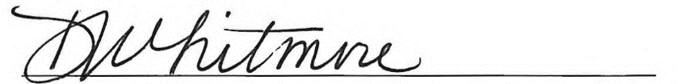
Detra Whitmore, Vice President of Community Engagement People & Culture Officer

Total population estimated by REMIX based on block groups intersecting the service area. May not match other published statistics.

